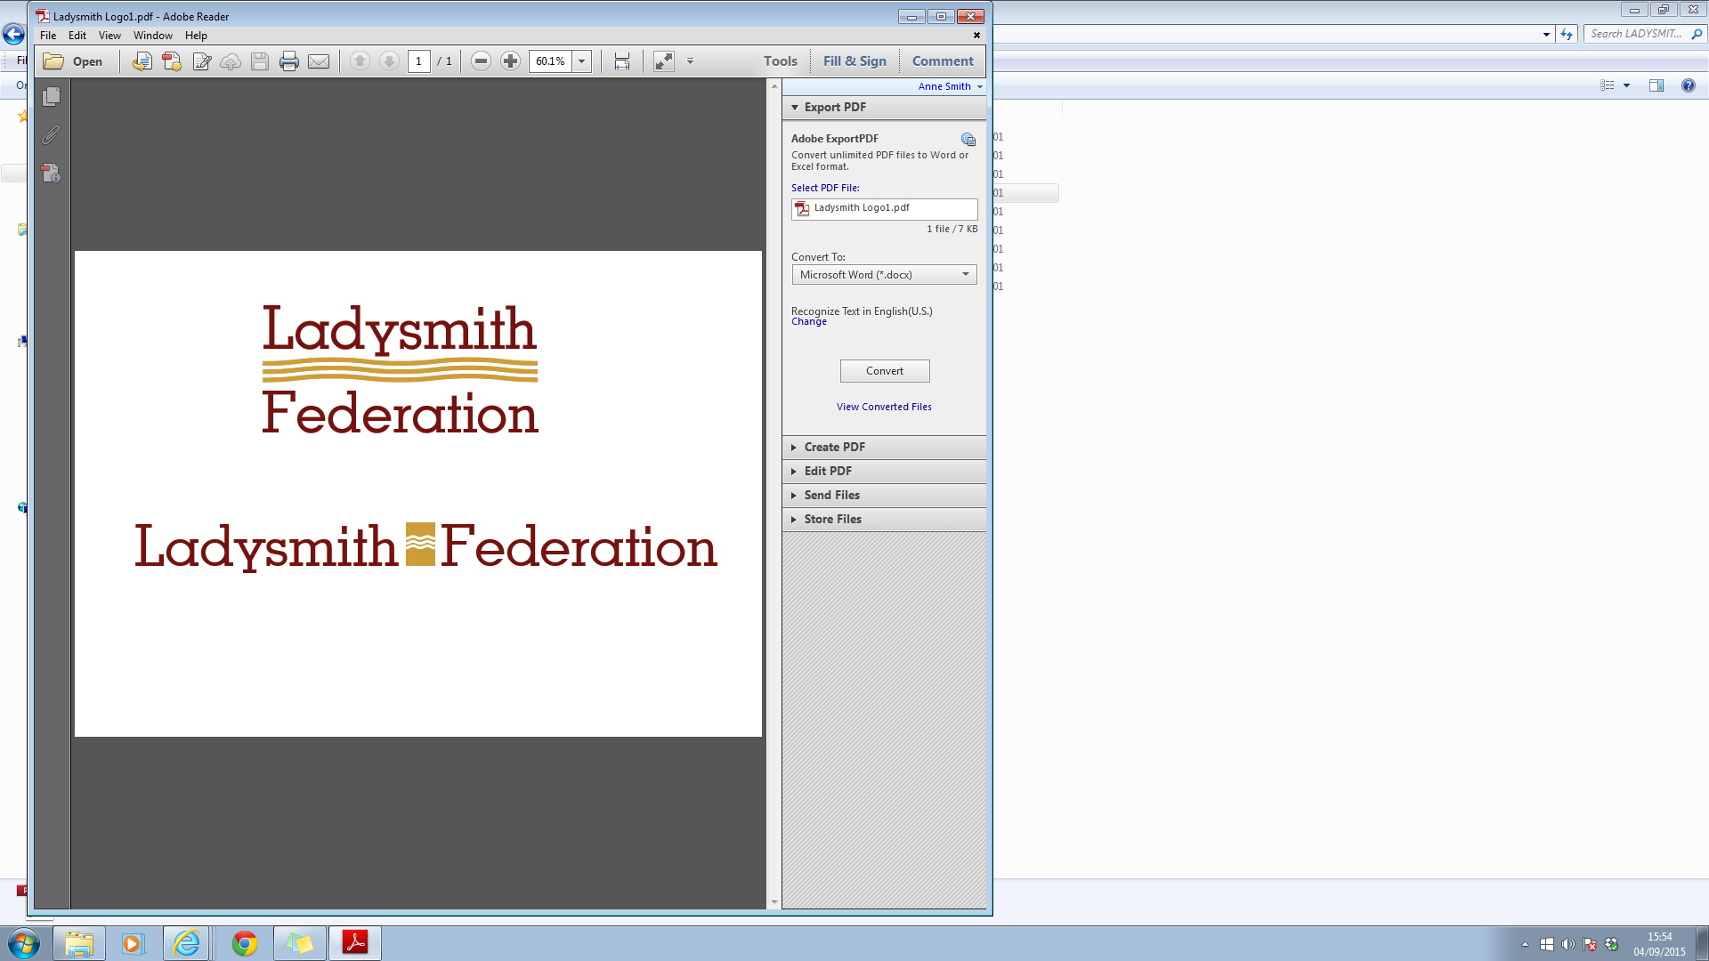

Ladysmith Infant and Nursery School

Dear Parents and Carers,

[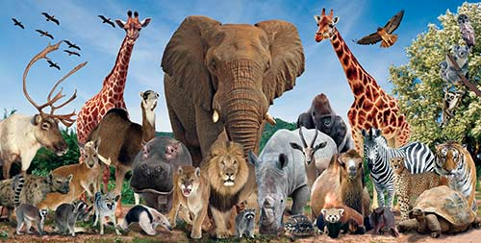](http://www.google.co.uk/url?sa=i&rct=j&q=&esrc=s&source=images&cd=&cad=rja&uact=8&ved=0ahUKEwic1YffrPfSAhXM8RQKHeC_B7EQjRwIBw&url=http://cargocollective.com/starz8/wild-animals&bvm=bv.150729734,d.ZGg&psig=AFQjCNH5R7HyNgdCvSIM-pssYXbSKFi-VA&ust=1490726932654625)We will be having our Hook Day for our topic about ‘How Animals adapt to their Environment’ on **Monday 16th April**. **We would like the children to come dressed as a wild animal** (preferably not a pet) and we will be spending the day learning about where the animals come from and why they live in different places in the world.

We will be cooking, making an environment for a jungle animal and using clay to make an animal model. It would be really lovely if the children could do a little research into their animal so that they know where they come from and any other interesting facts that they would like the class to know about.

**Please could your child bring in a box, either the size of a shoe box or smaller, to make an animal environment. We need the boxes either before the Easter holiday or on Monday 16th April.**

Please see the curriculum overview for further details about what we will be covering over the next half term.

We hope to visit the junior school field for athletics during the summer term and will let you know which day the children will need to bring trainers.

We hope that you all have a wonderful Easter break and that the sun begins to shine! We look forward to seeing you all for the summer term.

Many thanks,

Year 1 Team******

G:\COMMON FILES\COMMON FILES\Year 1\Summer term letter yr1 2018.docx