English
- Focusing on joining our letters using cursive script.
- Learning about class animals and writing an information leaflet all about them.
- Reading and retelling the story of Duffy’s Lucky Escape.
- Enjoying whole class stories and non-fiction books.
- Can you help your child to read and write the Year 2 words? Please also check that they know the Year 1 words too.

Maths
- Looking at Place Value and how this can help with addition and subtraction.
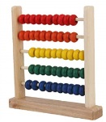
- Number talk – using our words to explain mathematical thinking.
- Understand and use mathematical language (more, less, most, fewest, tens, ones, place value)
Ask me to add and subtract simple sums and explain how many tens and ones are in different two digit numbers.

Year 2 Curriculum Autumn Term 2019
The Wonderful World of Water
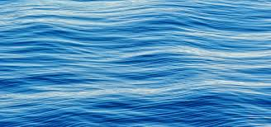
We are going to be exploring all things watery during this topic and celebrating the wonderful life-giving power that is water.

Science
- Learning about different habitats and what ocean animals need to survive.
- Learning about the properties of different materials and what they are most suitable for.
Geography and History
- Learning the names of the seven continents and five oceans of the world.
- Learning about Francis Drake and Ellen Macarthur and their routes of exploration.
- Ask me about the different oceans and continents as well as the different sea creature habitats.

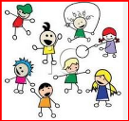
PE
- Games: simple team games, building core strength and developing co-ordination
- Yoga – enjoy Yoga stories about our class animals whilst stretching our bodies and holding balances to aid our gross motor skills.

Art, Music and DT
- Learning about observational drawings and how to use different types of drawing including water colours and powder paints to mix shades.
- Composing simple rhythms using early notation.
- Making simple models of boats to see if they would float.
- Can you ask me to draw you an observational drawing of my class animal? Please also find out what I know about my class creature.

