Ladysmith Infant & Nursery School

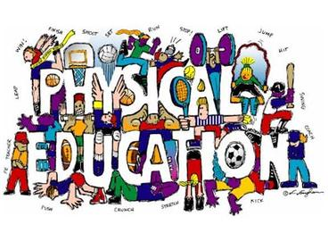
Year 2 PE Kits
Children in Year 2 are going to be having PE lessons on a Wednesday and Friday. Therefore, please provide your child with a suitable PE kit to be left in school until half term. This needs to include a t-shirt, shorts or jogging bottoms and trainers.
Please remember to name all clothing to avoid items going astray.
If there are any problems or questions please do not hesitate to ask a Year 2 member of staff.
Many thanks,

Year 2 team

G:\COMMON FILES\COMMON FILES\Year 2\Year 2 PE Kits 2017.docx

