INFANT AND NURSERY SCHOOL
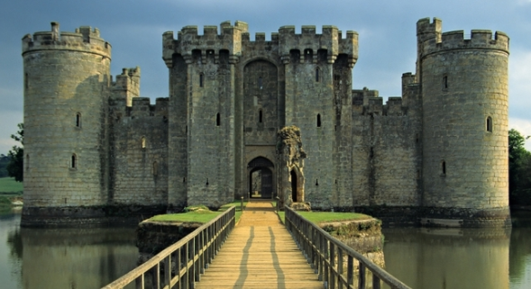

Dear Parents and Carers,
We will be having our Hook Day for our topic about ‘Who lived in a castle?’ on Monday 30th October. We would like the children to come dressed in medieval costume and we will be spending the day learning about medieval life. We will be making a board game, designing and making a crown and shield, cooking a medieval recipe and listening to medieval music. Any long dress that you might have, Robin Hood/ knight type of costume, shorts and a shirt or a long tunic that looks medieval would be great! Please don’t feel that you must go and buy an outfit!
We hope to finish our topic on castles with a Medieval Banquet that will double up as our Christmas party! They will need their costume for this day too! We will give more details about the banquet next term.
Please see the curriculum overview for further details about what we will be covering over the next half term.
Please could you name all clothing with YOUR child’s name. We have been getting in quite a muddle after PE when there is no name in clothing!
9.45am
Christmas Performances
Bumblebee -Monday 4th
Dragonfly -Tuesday 5th
Butterfly - Thursday 7th December, 2017.
We hope that you all have a wonderful half term break.
We look forward to seeing you all soon!
Many thanks,

Year 1 Team.

G:\COMMON FILES\COMMON FILES\Year 1\Autumn 2 term letter castles.docx

