

**Habitats and Growing.**

**Reception Spring Term 2 Overview**

Focus on the Characteristics of Learning:

**20.2.17– Strategy Squirrel**

(Choosing how to do things and solving problems to reach their goal).

**06.3.17– Playful Pup**

(Enjoy playing happily with others, acting out past experiences, events and stories).

*Please ask if you are not sure what the animals represent or how we use them. We’d love your views on how your child takes on these characteristics as he/she plays and*

*learns.*

**PRIME AREAS**



In Personal and Social Education we will be:

* Learning about relationships with others.
* Learning how to ask for things without hurting others.
* Learning about our own and others people’s feelings



In Physical development we will be:

* Joining in with aerobic activities including “Go-Noodle” as a class
* Developing gross motor skills through using balls and rackets and keeping them under control.
* Developing fine motor skills through extending our core strength, pincer grips and joining in with “funky fingers” and “dough gym” activities
* Practising correct letter formation.



In Communication and Language we will be developing our speaking and listening skills, attention and understanding through:

* Listening to and discussing a vast range of stories and texts
* Learn and acting out stories by heart.
* Talking about our learning using the animal characters.
* Asking questions to find out more.
* Talking about our likes, dislikes, strengths and feelings.
* Listening to each other and joining in conversations.

**SPECIFIC AREAS**

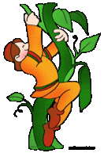

In Literacy we will be:

* Learning the story of Jack and the Beanstalk by heart.
* Continuing to recognise grapheme (letters), say, write and blend phonemes (letter sounds).
* Extending digraphs and trigraphs knowledge (two/three letters that make one sound) and extending tricky word knowledge.
* Sharing a range of texts written by Nick Butterworth.
* Using non-fiction books to find out more.
* Labelling pictures, making lists, making story maps, writing captions and simple sentences (using capital letters at the beginning, finger spaces and a full stop at the end).

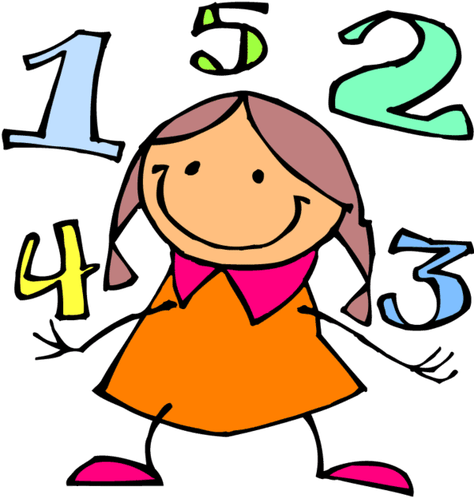

In Mathematics we will be:

* Learning which digit represents numbers and their order (to 20).
* Partitioning numbers and realising that there are different ways to make the same number.
* Talking about times of the day, routines and days of the week.
* Extending our knowledge about length, height and weight and how we measure these things.



Understanding the World through:

* Looking at similarities, differences, pattern and change in animals and their different habitats.
* Growing plants.
* Using different types of technology to support our learning.
* Learning about Pancake day/Easter.



Expressive Arts and Design

* Exploring different media to create representations of plants/our own ideas.
* Learning how to use tools correctly to create effects.
* Developing role play to support retelling the story of Jack and the Beanstalk