Write a …..
Film Review
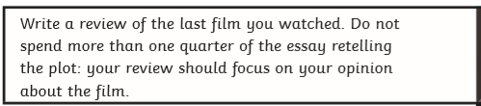

Story called Classroom Conundrum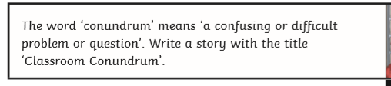
Letter to Local MP Ben Bradshaw 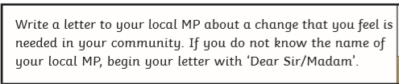
Or give your views and advice to Boris Johnson!

Continue the story…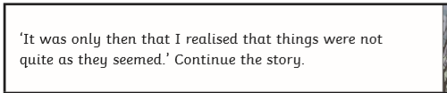

Story called The Ascent