**Day 1 Addition subtraction**

Mental methods:

1. 679 + 42 =
2. 68 + 1009 =
3. 5678 + 25 =
4. 6001 – 78 =
5. 8092 – 103 =
6. 8002 + 1905 =
7. 498 + 578 =
8. 9074 – 1008 =

Written methods of addition:

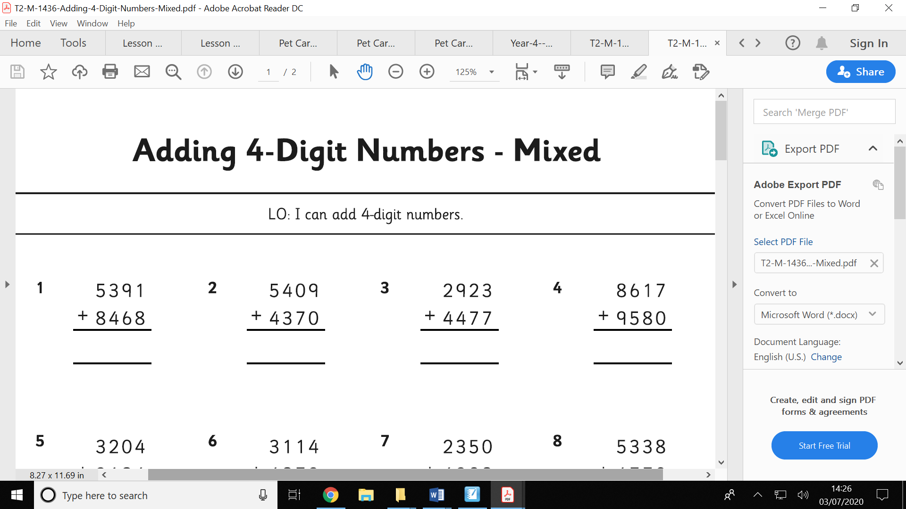

Written methods of subtraction:

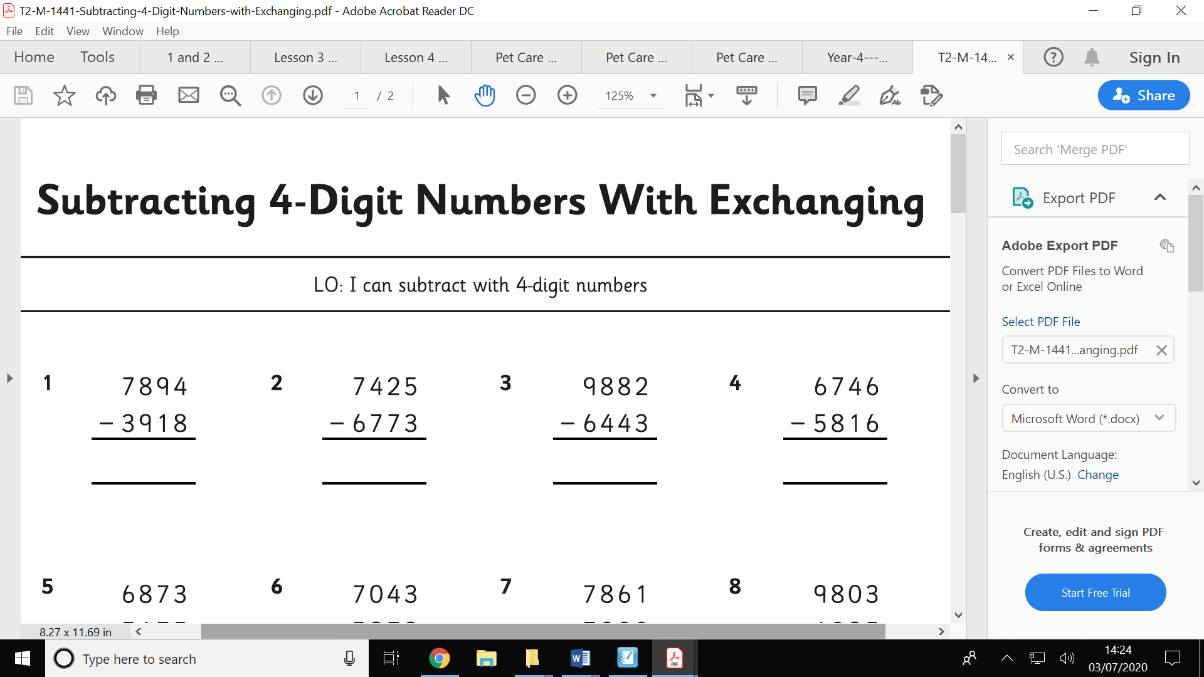

Fill in the missing numbers:

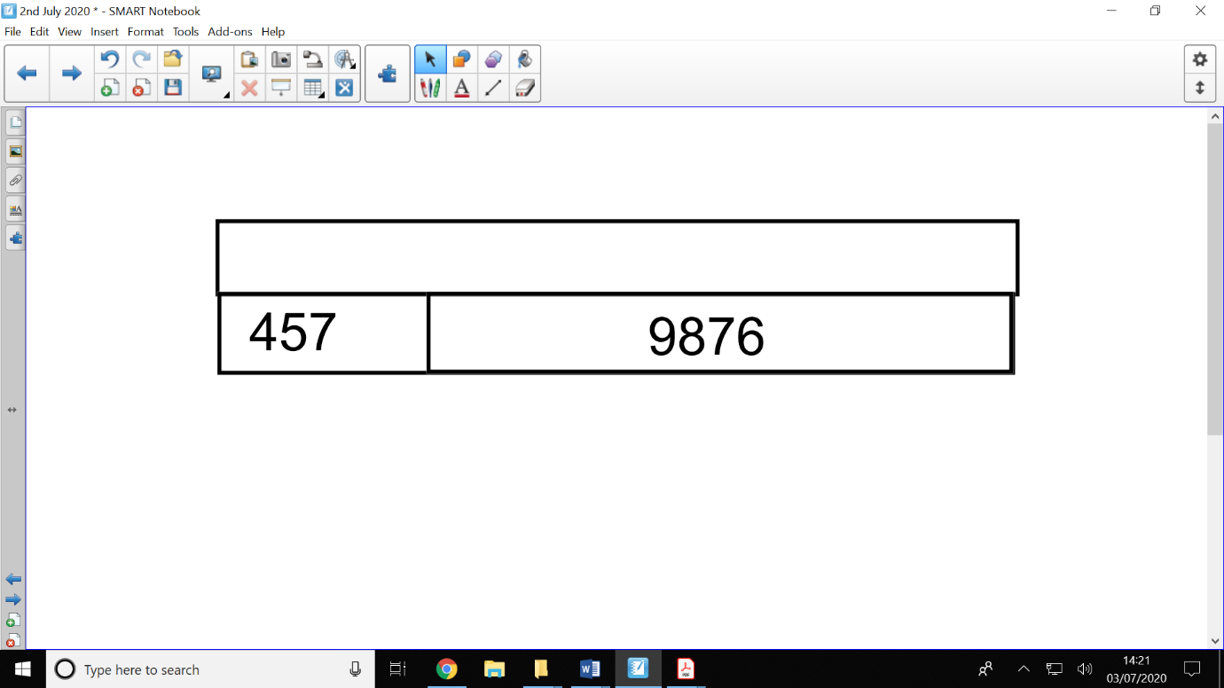

2. Complete the bar models:

