**PRIME AREAS**



In Personal and Social Education we will be:

* Learning about setting and achieving goals.
* Learning to wait and take responsibility.
* Listening to others and working together to reach goals.

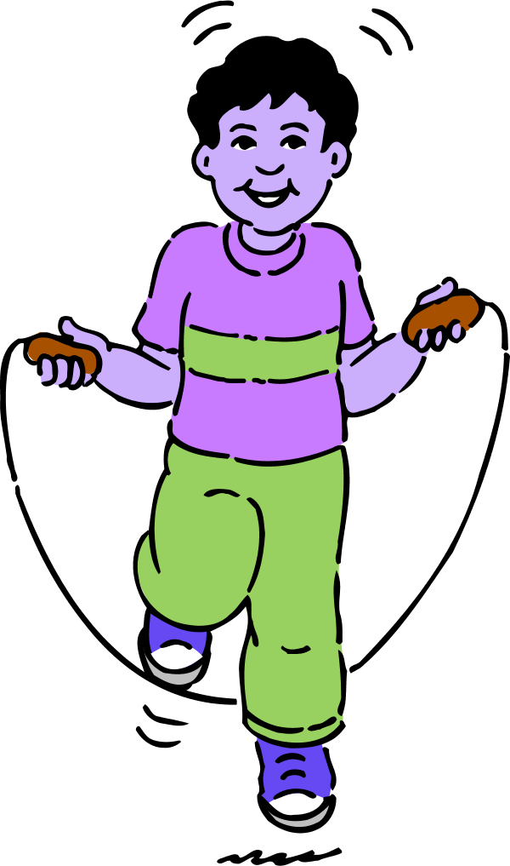

In Physical development we will be:

* Joining in with aerobic activities including “Go-Noodle” as a class
* Developing gross motor skills through moving freely with confidence, in different ways and linking a set of moves together.
* Developing fine motor skills through extending our core strength, pincer grips and joining in with “funky fingers” and “dough gym” activities



In Communication and Language we will be developing our speaking and listening skills, attention and understanding through:

* Listening to and discussing a vast range of stories and texts
* Learn and acting out stories by heart.
* Talking about our learning using the animal characters.
* Listening to each other and joining in with conversations.



**Habitats**

**Reception Spring Term 1 Overview**

Focus on the Characteristics of Learning:

**4.1.17 – Achieving Beaver.**

(Enjoy achieving what they set out to do and how they did it.)

**23.1.17 – Linking Spider**

(Making links and noticing patterns in their experiences.)

**6.2.17– Strategy Squirrel**

(Choosing how to do things and solving problems to reach their goal).

*Please ask if you are not sure what the animals represent or how we use them. We’d love your views on how your child takes on these characteristics as he/she plays and*

*learns.*

**SPECIFIC AREAS**



In Literacy we will be:

* Learning the story of “We’re all going on a Bear Hunt” by heart.
* Continuing to recognise grapheme (letters), say, write and blend phonemes (letter sounds).
* Learning digraphs and trigraphs (two/three letters that make one sound) and extending our tricky word knowledge.
* Sharing a range of texts written by Nick Butterworth.
* Using non-fiction books to find out more.
* Labelling pictures, making lists, writing captions and simple sentences.

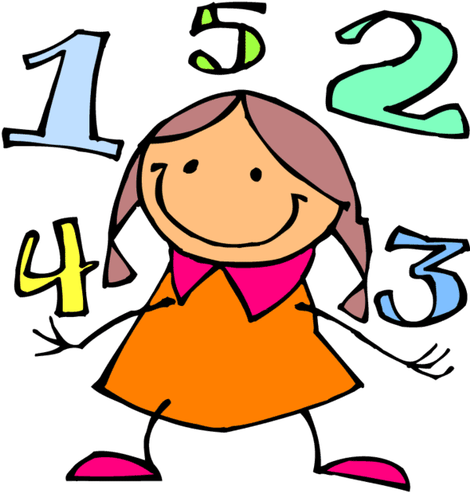

In Mathematics we will be:

* Learning which digit represents numbers and their order (to 20).
* Looking at patterns in numbers, halving and doubling.
* Learning about 3D shapes and their properties.



Understanding the World through:

* Finding out about different habitats and what may live there.
* Looking at similarities, differences, pattern and change in animals and their different habitats.
* Finding out about animals and their different habitats around the world using ICT.
* Learning about Chinese New Year.



Expressive Arts and Design

* Exploring different media to create representations of animals, their patterns and their habitats.
* Learning how to use tools correctly to create effects.
* Exploring percussion instruments and using them to help tell a story.