Tutorial for logging on and using Seesaw at home
Logging in
- Download the Seesaw Class app from Apple Store or Google Play Store OR type app.seesaw.me into your browser.

- Click

- Copy and paste the home learning code that has been emailed to you into the Text Code box and press Go.
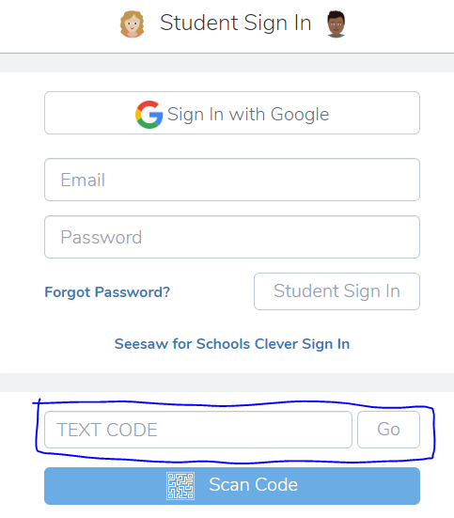

Inbox
- In the Inbox, you will see a welcome message from your class teacher/s. The inbox is where you will see any whole class messages that have been sent by the teacher/s.
Please note that you will not be able to message a teacher through Seesaw. Please see the end of this tutorial for a reminder on how to contact your child’s teacher/s.
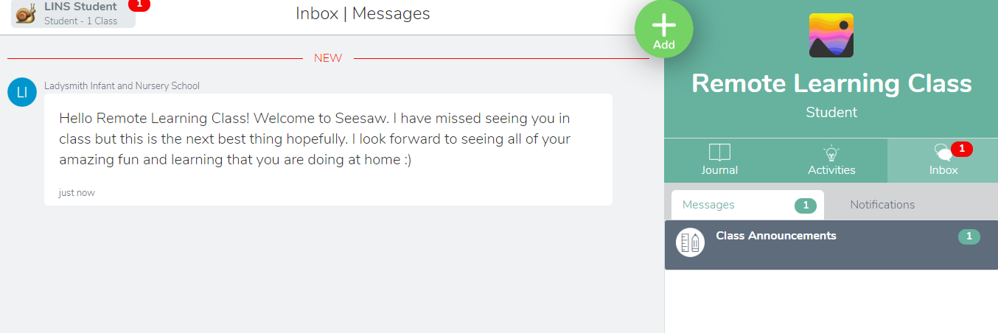

Journal
- Your Journal is where all the work that you do is displayed. When you first sign in there will not be anything, as the first learning drop is going to be on Wednesday 15th. However, if you would like to, you can upload to your journal and share some of the things that you have been doing at home. Click Add to upload any videos or photos that you would like to share with your teacher/s. Alternatively, you may want to write/record them a message back.
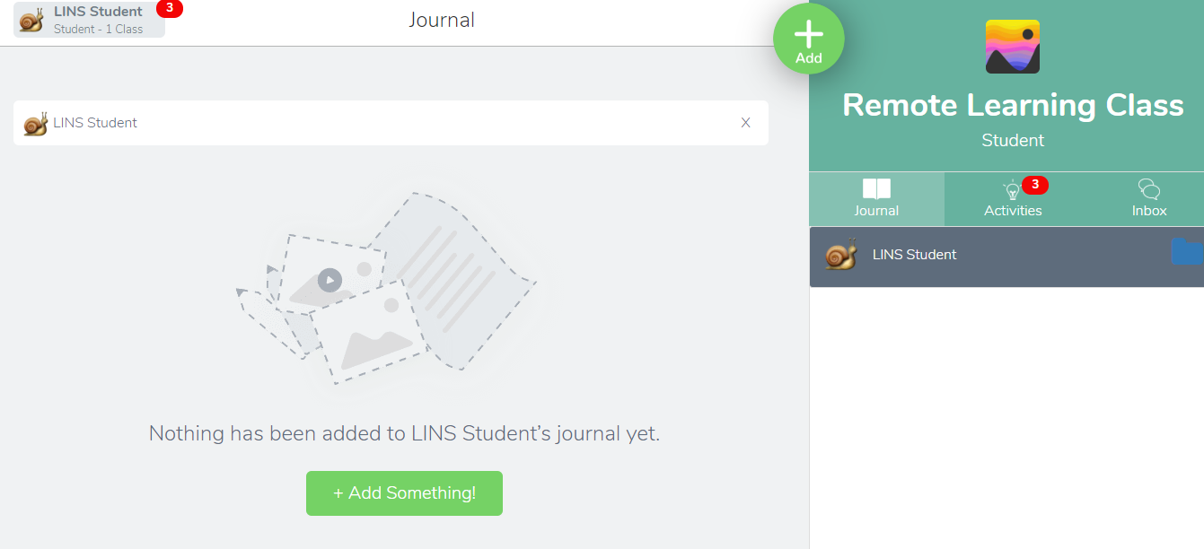

- It is very simple to upload content to your Journal. Just click on one of the following icons:

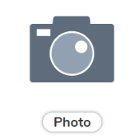
  - Takes a Add a photo using the camera on
your device.

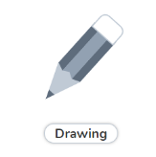
  - Draw, take a picture or record a voice
message all in one place.

  - Records video using the camera on your
device.
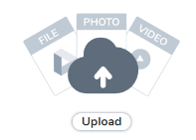
  - Upload files from your device or from
Google Drive.
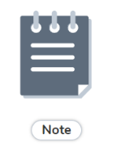
  - Type notes on lined paper or record voice
notes.
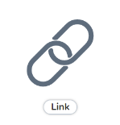
  - Link videos from YouTube, iPlayer or other
online sources, by copying and pasting the
URL.

- Your response to an activity that your teacher/s sets will also be displayed in your Journal. Your responses will be sent back directly to your teachers where they will approve your work. Teachers can also comment on your work. This will show up underneath the activity in the comments section. You can also leave a comment for the teacher/s to read.

Activities
- Activities is where the work that your teacher/s set you will be displayed. The work will be designated RED, AMBER or GREEN.
  - RED – This work must be done (priority to complete)
  - AMBER – This work should be done
  - GREEN – This work could be done
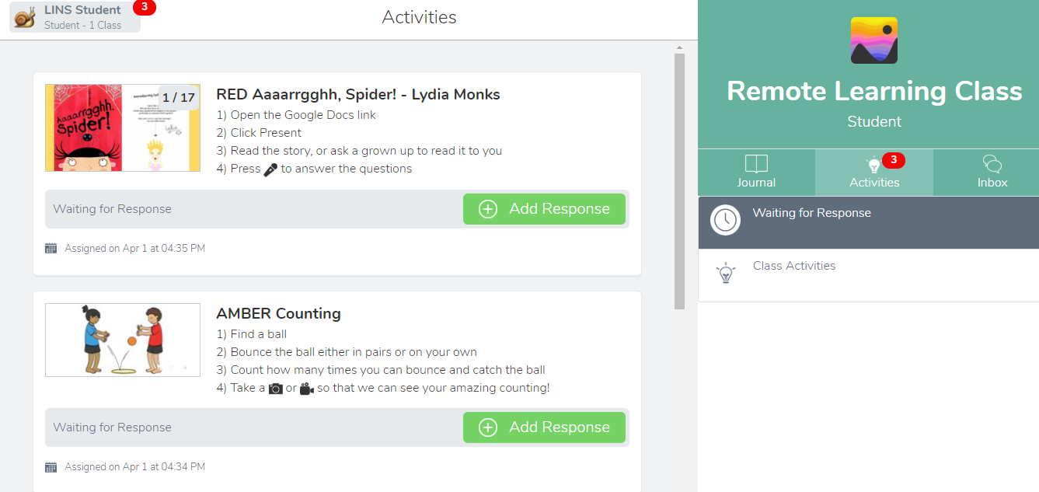

- All activities will come with a set of instructions. These will be very clear, but your child may need a little help to understand exactly what they need to do especially at the beginning. There will be several ways in which your child can respond to an assignment, all of which can be done either on Seesaw or using resources in your home. There will never be any need to print out work.
10) In order to respond to the activity, your child needs to click

Some activities have templates for your child to work directly onto. Other activities require a video response or a photo of your child’s work. The method of response will be made clear in the instructions.

- Some activities may direct your child to a linked YouTube video, a short programme on BBC iPlayer or other website or video links. These will always be appropriate for the activity but please be aware that children may need supervision at this stage to ensure that they return to Seesaw to complete their activity.

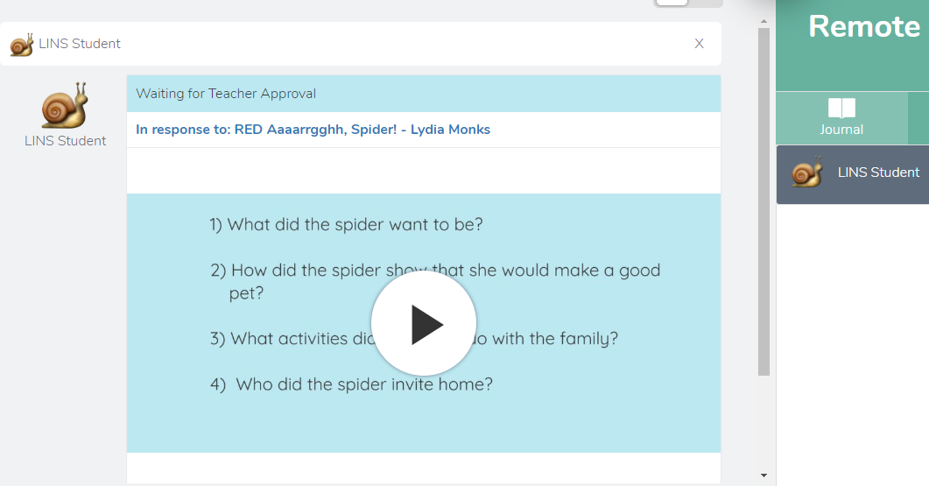
12) Once your child has completed their activity, they need to click and their work will be sent to their teacher/s for approval. The completed activity will be shown in the journal.

13) Once a post has been approved and commented on by the teacher/s, this will show up in your Inbox notifications so that you can see.
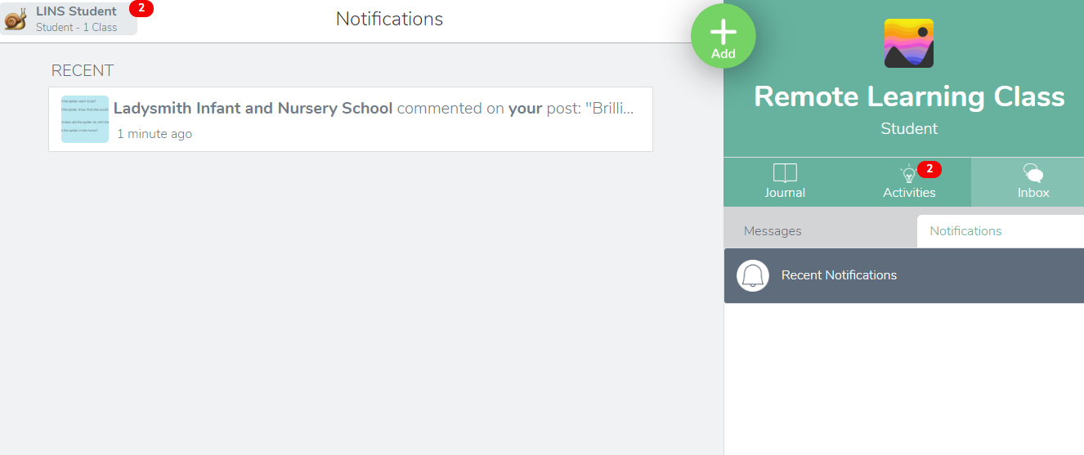

You can click on the notification to view the post and the comment.
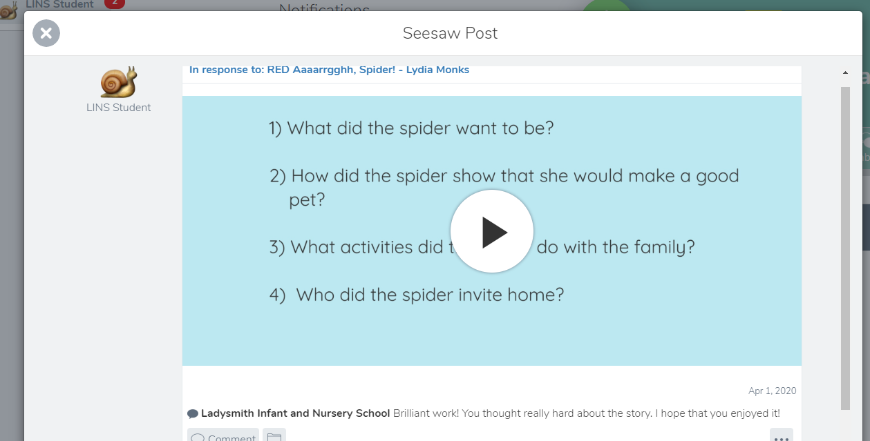

- When you are ready to complete another activity, click on
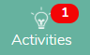
and click

- At no point should you be able to see work by any other student, unless the teacher/s chooses to share someone’s work with the rest of the class. If you do see another child’s work, please contact the teacher/s immediately so that this can be rectified.

Final Note
As previously stated, there will be 3 ‘Learning Drops’ throughout the course of a week (Monday, Wednesday and Friday by 10am) with a variety of activities which will be designated RED, AMBER or GREEN.
Please contact the teacher/s if you are having any problems completing the activities and they will get back to you within 48 hours. This is a huge learning curve for us all and we would greatly appreciate your feedback.
To offer feedback as to how Seesaw is going for you, or to contact your class teacher/s please write an email to the relevant address, stating your child’s name and class in the subject box:
Year1support@ladysmithfederation.net
Year2support@ladysmithfederation.net

See you soon on Seesaw!

