Year 4 suggested timetable week beginning 18.5.20

We’ve not timetabled TT Rock stars, Study Ladder or independent reading, but please encourage the children to do these too! The timings are just suggested as a guide.

Monday
PE (30mins) – Join in with PE with Joe, live at 9am
Maths (30mis) – Watch the tutorial, complete the worksheet and mark it.
Writing (30mins) There are two suggestions for writing this week – Route 1 or Route 2. Choose which one you prefer.
Route 1: Choose what you will right about, either your own choice or one of the three suggested activities from the tutorial ‘Writing about the Olympics’. Research and plan the structure, layout and content of your writing.
Route 2:
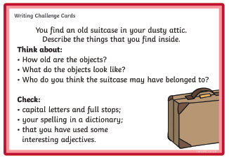
Reading (15mins) – Watch the final chapters of ‘The Wooden Horse’ and try to summarise the whole story in a paragraph or less.
Topic (30mins) – Collect the materials you will need to make an Olympic wreath (see separate document).

Tuesday
PE (30mins) – Join in with PE with Joe, live at 9am
Maths (30mis) – Watch the tutorial, complete the worksheet and mark it.
Writing (30mins) – Route 1: Start to write paragraph 1.
Route 2:
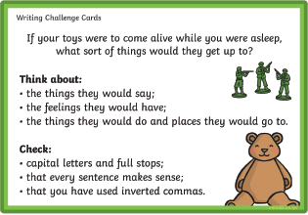
Spelling (15mins) – Practise spellings on Spelling Shed.
Topic (30mins) – Piece together your Olympic wreath. It can be worn by the winner of the Olympic board game or of your own home Olympic games!

Wednesday
PE (30mins) – Join in with PE with Joe, live at 9am
Maths (30mis) – Watch the tutorial, complete the worksheet and mark it.
Writing (30mins) – Route 1: Start to write paragraph 2.
Route 2:
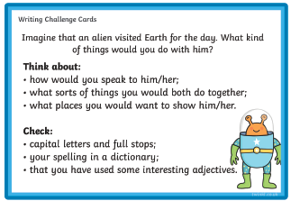

Reading (20mins) – Complete the Olympics reading comprehension.
Science (30mins) – Go on a mini beast safari! (See sheets for a recording sheet and more instrucitons)

Thursday
PE (30mins) – Join in with PE with Joe, live at 9am
Maths (30mis) – Watch the tutorial, complete the worksheet and mark it.
Writing (30mins) – Route 1: Start to write paragraph 3.
Route 2:
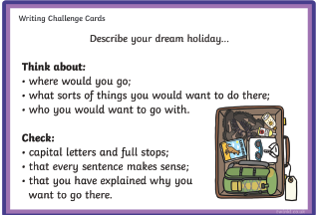
Science (30mins) – Insect symmetry activity- See Miss Rowden’s tutorial for more help.
Spelling (15mins) – Practise spellings on Spelling Shed.

Friday
PE (30mins) – Join in with PE with Joe, live at 9am
Maths (30mis) – Friday Challenges (blue and orange- similar to last week)
Writing (30mins) – Route 1: Complete your writing.
Route 2:
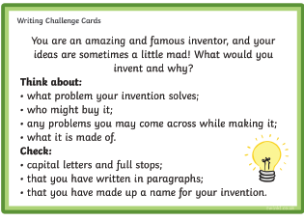
Reading (15mins) – Read your school library book- have you taken a quiz recently?
Art (30mins) – Create your own piece of Olympic art inspired by the colours and shapes of the ring symbols. Take a look at the pictures on the separate document for help.

