Ladysmith Infant & Nursery School

Year 1 Phonics and Farm Trip Talk
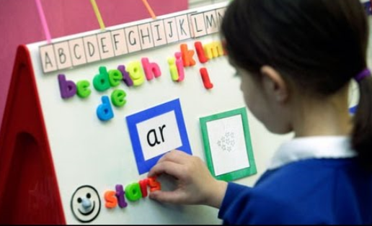
Monday 18th September 2017 at 2.30pm
Dear Parents and Carers,

We would like to invite you to a talk about how we teach phonics in Year 1 and we hope that you will be able to attend this presentation, as it will give you useful information and skills to enable you to support your child at home. You will be able to listen to how each phoneme sounds and have a revision session about how phonics is taught through Letters and Sounds.

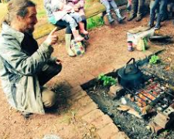
This will be followed by a talk from Kevin Cotter from Organic Arts. We are planning to take the children to Westtown Farm in October so that the children can learn about life on a farm. We hope to run three visits over the year so that your children can experience the farm in different seasons. During the first visit, we are planning to harvest pumpkins, make soup and learn about the animals that live on the farm. Kevin would like to talk to you about the aim of the farm days so that you have a clear idea of why we are planning three visits.

Please come to the school hall on Monday 18th September at 2.30pm. Everyone who attends will be entered into an exciting free raffle draw. You will be able to collect your child from school at the normal time of 3.20pm. You will be able to come through reception to access the hall.

We very much look forward to seeing you.

Many thanks,
Hannah Pounds (Year 1) and Karen Featherstone (Literacy)

