Calculation Policy - Multiplication and Division
November 2018

John Holt says: A pupil understands a mathematical concept, idea or technique if he or she can:
- describe it in his or her own words;
- represent it in a variety of ways (e.g. using concrete materials, pictures and symbols);
- explain it to someone else; make up his or her own examples;
- see connections between it and other facts or ideas;
- recognise it in new contexts or situations;
make use of it in various ways.
These beliefs underpin our teaching and assessment of mathematical understanding at Ladysmith Infant and Nursery School.

Foundation Stage

The end of year expectation for the Foundation Stage is that children will be able to ‘solve problems involving doubling, halving and sharing.’

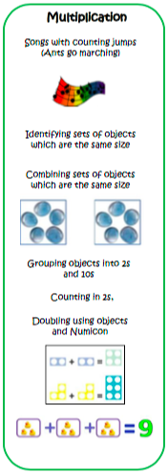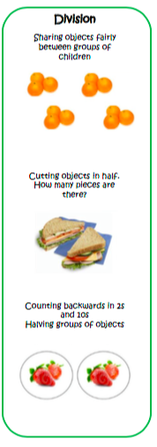
Year 1.
Children are expected to:
- Count in multiples of twos, fives and tens. A child’s first introduction to multiplication will be through counting in steps of either 2, 5 or 10. Use of concrete objects will enable them to grasp this concept more quickly.
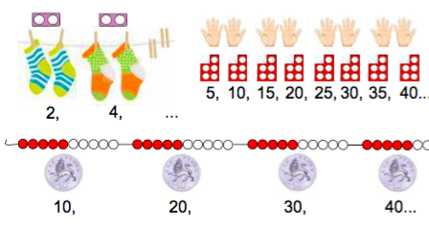

Number lines can also support children when they multiply, as a way to add on and count in steps.
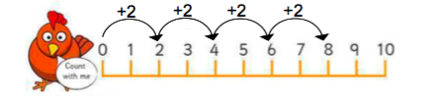

Children could use a counter, a finger or a pencil to help them ‘hop’ along the number line. They should begin to look at counting backwards in these steps as well.
When counting in 2s, children may start to recognise the difference in structure between odd and even numbers.
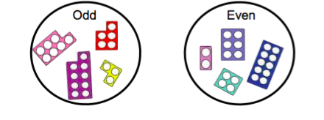

Solve one step multiplication or division problems using concrete objects, pictorial representations or number arrays.
By grouping or sharing small quantities, children should begin to gain some understanding of multiplication and division.
At this stage, they will solve simple problems using repeated addition, although the language of multiplication will also be introduced.
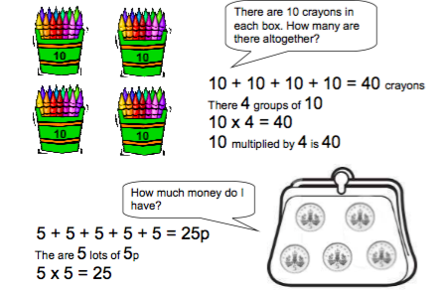
Children will become familiar with the concept of division through sharing and grouping concrete objects equally.
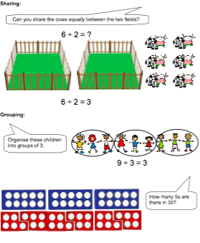
Arrays will also be used to help children visualise and understand multiplication and division
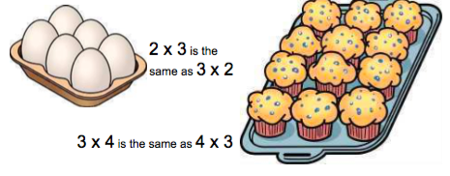
These everyday items, arranged in rows and columns, highlight an important multiplication fact to the children: that multiplication can be done in any order (commutative).
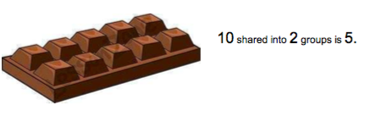
Find and name a half of a quantity as two equal parts, or a quarter of a quantity as four equal parts.
Children should begin to explore finding simple fractions of quantities, such as 1/2 and 1/4. In particular, they will be expected to have some understanding of doubling and halving.
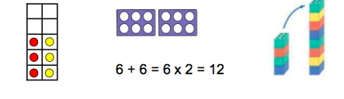

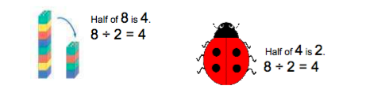

Children should be shown that halving and dividing by 2 are the same.
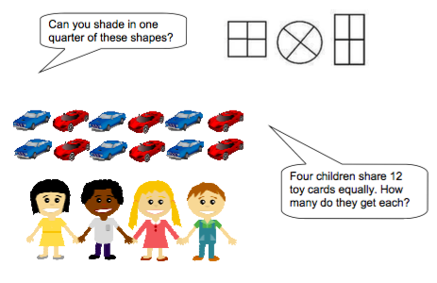

• Vocabulary Ones, groups, lots of, doubling repeated addition, groups of, lots of, times, columns, rows, longer, bigger, higher, times as (big, long, wide etc), share, share equally, one each, two each, group, groups of, lots of, array.

Year 2

Teaching Multiplication clip https://www.youtube.com/watch?v=YPWmOVt8vgw&list=PLQqF8sn28L9yj34NpXK7Yffze7ZoXTiix

Children are expected to:lication and Division
• Count in multiples of two, three, five and ten, both forwards and backwards.
Children will continue to practise counting in steps of 2, 5 and 10, so that they become increasingly fluent at doing so. They will also be expected to count backwards from a given number in these steps.

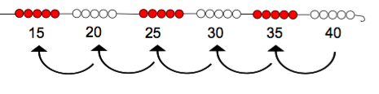
Furthermore, they must now be able to count up from 0 in threes.
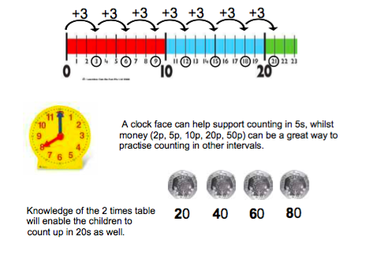
• Recall and use multiplication and division facts for the 2, 5 and 10 times tables. The children should now be able to recall, from memory, multiplication facts for the 2, 5 and 10 times tables. They could use this knowledge to solve a variety of missing number problems:
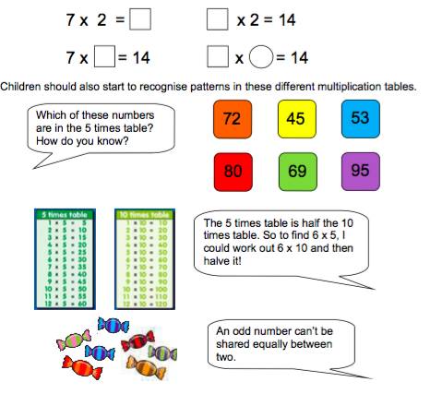

The use of Numicon can help children build internal, visual structures of numbers, and thus elicit a much more secure understanding of the difference between odd and even numbers.

• Calculate multiplication and division statements within the multiplication tables and write them using multiplication (x), division (÷) and equals (=) signs.
Multiplication: Children should continue to use grouping or number lines to calculate other unknown multiplications, developing their understanding of multiplication as repeated addition.
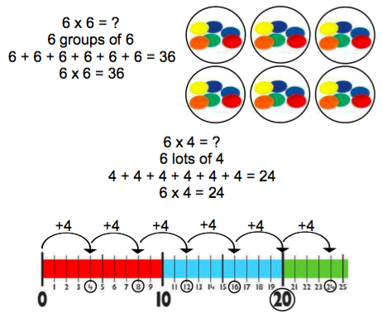

Some children may be able to use a blank number line to record their mental processes:
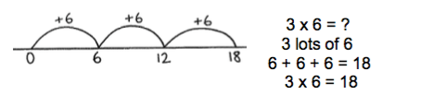

As well as knowing doubles up to 10 + 10, children should use these known facts to double bigger, 2-digit numbers.
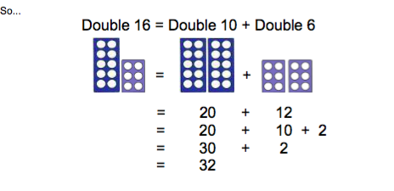

Children may want to use informal jottings when presenting this strategy:
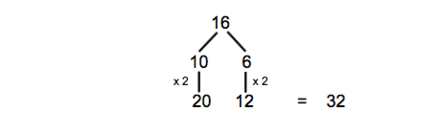
The principles of division should continue to be taught through grouping and sharing.

Grouping: When grouping, you count the number of groups you have made.
For instance, 15 ÷ 3 = 5 can be viewed as ‘How many groups of 3 are there in 15?
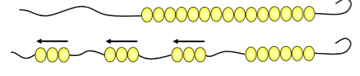
Blank number lines, or even fingers, can support the same line of thinking:
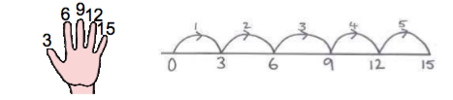

These strategies will also help children make the link between multiplication and division. Sharing: When sharing, we count the number of objects in each group.
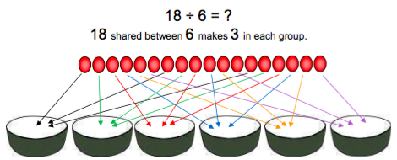
Children should also be given the opportunity to find a half, a quarter and a third of shapes and quantities. Finding a fraction of a number should be related to sharing and division.
• Show that multiplication of two numbers can be done in any order (commutative) but that division of one number by another cannot.
By creating, and looking at, arrays, children will begin to recognise the inverse relationship between multiplication and division.
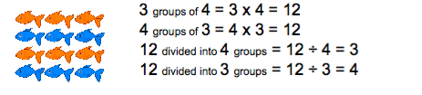

Eventually, children should be able to answer questions like: “If 12 x 2 = 24, what is 24 ÷ 2?”
• Vocabulary multiple, multiplication array, multiplication tables/facts, groups of, lots of, times, columns, rows, group in pairs, 3s 10s etc, equal groups of, divide, ÷, divided by, divided into, shared into, remainder.

.

