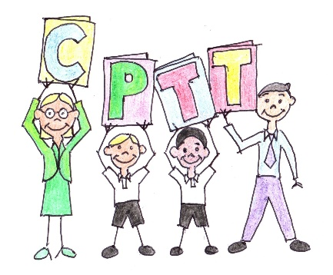

CPTT Parent, child and teacher reps 2017/18

Nursery & Infant School:
Year / Class | Teacher | Parent | Child
Nursery | Sarah John | Charlotte Lewis | Stan
 |  | Camilla Goodchild | Lilianna
Reception: rabbit | Amy Youde | Helen Shipway | William
Reception: squirrel |  | Karen Hanbury | Lily-Blue
Reception: hedgehog |  | Jane Richardson | Ben
Year 1 | Sarah John | Victoria Matthews | Annabelle
 |  | Naomi Cronk | Beatrice
 |  | Hannah Oram | Matilda
Year 2 | Helen Potter & Carrie Slack | Lindsay Purwanan | Zico
 |  | Marie Fieldhouse | Abi
 |  | Donna Biddulph | Zac
 |  | Jen Harris | Elsie

Junior School:
Year / Class | Teacher | Parent | Child
Year 3 | Neil Williams | Hannah Waterfield Alex Dolphin (deputy) | Jack  Tomas (deputy)
 |  | Kate Holmes | Rosie
 |  | Olivia Harker | Henry
Year 4 | Alison Nyeko | Catherine Bartle | Lucy
 |  | Missing Rep | Missing Rep
 |  | Robert Boyd  Hannah Pounds (deputy) | Alexander  Tom (deputy)
Year 5 | Ana Salter | Bill Blight | Leah
 |  | Jemma Searle  Alex Dolphin (deputy) | Evie  Isabel (deputy)
 |  | Vanessa Johnson | Stanley
Year 6 | Jane Ellis | Emma Watson | George
 |  | Emma Tilbury | Cerys
 |  | Livia Stan | Raisa
 |  | Cassie Monkman | Millie Rosa
 |  | Ed Drew | Ollie

