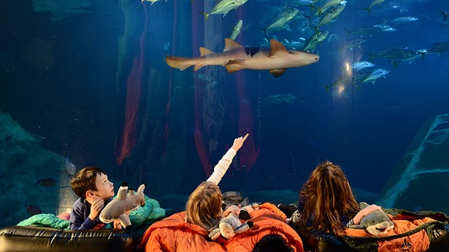
Ladysmith Junior School
Pretoria Road
Exeter
Devon EX1 2PT

Telephone: 01392 255554
Facsimile: 01392 496603

Web: www.ladysmithfederation.net
Email: junior.admin@ladysmithfederation.net

Headteacher: Mr Mark Wilkinson

23rd February 2018

Dear Parents / Guardians,
We would like to offer the year 4 children an opportunity to take part in a mini residential next term - Sleeping with the Sharks at Plymouth Aquarium on Thursday 24th May 2018.
Sleeping with the Sharks is an exciting new way to see what happens at night in the underwater world. The evening is aimed at getting across a greater understanding of the marine environment and how we all have a part in helping to keep it safe. We will leave school at 5.00pm and travel by coach to arrive for activities to start at the aquarium at 7pm.
Activities will include: a twilight tour; a chance to see what the fish get up to at night; arts and crafts in the Just Add H2O Creative Centre; games around the building; big screen movie in front of the Eddystone Reef tank; midnight snack and a continental breakfast in the Waves Café.
After breakfast (provided at the venue), we will have time to have a walk nearby.
We will return to the aquarium ready to meet our coach at 11am, returning to school at 12:00 noon. The children are then welcome to go home for the rest of the day to catch up with sleep! Any children who are not picked up are able to remain at school and will take part in some quiet activities for the afternoon until 3.30pm.
The trip will cost £42.50 (£21.25 for children in receipt of the Pupil Premium Grant) and if your child would like to go, please complete the form below, or alternatively, you can complete consent online through ParentMail and pay the deposit of £10 (£5) by Friday 9th March so places can be confirmed. Using the ParentMail is the preferred method, but alternatively you can pay the initial deposit in cash. However, we become a cash-less school after the Easter holidays, so the remainder will need to paid through ParentMail. A guide to on-line payment can be found at: https://www.parentmail.co.uk/help/parenthelp/payments/online-payments/

Full details of equipment/clothing/food etc. will be sent in due course.

Yours sincerely
Year 4 Team
Mini residential to Plymouth Aquarium. Please return to your child’s class teacher or the school office by Friday 9th March. If you pay online, you do not need to return a hard copy of this letter.
Hard copies of this letter are available from reception.

Child: ......................................................................................................... Class: ............................

[ ] I give permission for my child to attend a night Sleeping with Sharks at Plymouth Aquarium on Thursday 24th May 2017
[ ] I enclose a deposit of £10 / full payment of £42.50 (please delete)
[ ] My child is entitled to the Pupil Premium Grant* Therefore, I enclose a deposit of £5 / full payment of £21.25 (please delete)

*This means that if you are eligible for Free School Meals, the school is in receipt of the Pupil Premium for your child. The Pupil Premium is a fund to support your child’s education financially by making payments and subsidies for a range of learning activities. If you think you are eligible please pick up a leaflet from the reception area or phone: 0845 1551019

Signed: .................................................................... Date: ......................................

