Friday 27th November 2015

Year 6 Motivational Workshop
On Thursday Year 6 enjoyed a Motivation Workshop, where they spent the day in the hall engaged in a variety of fun, motivating games and activities. The key messages throughout the day were:
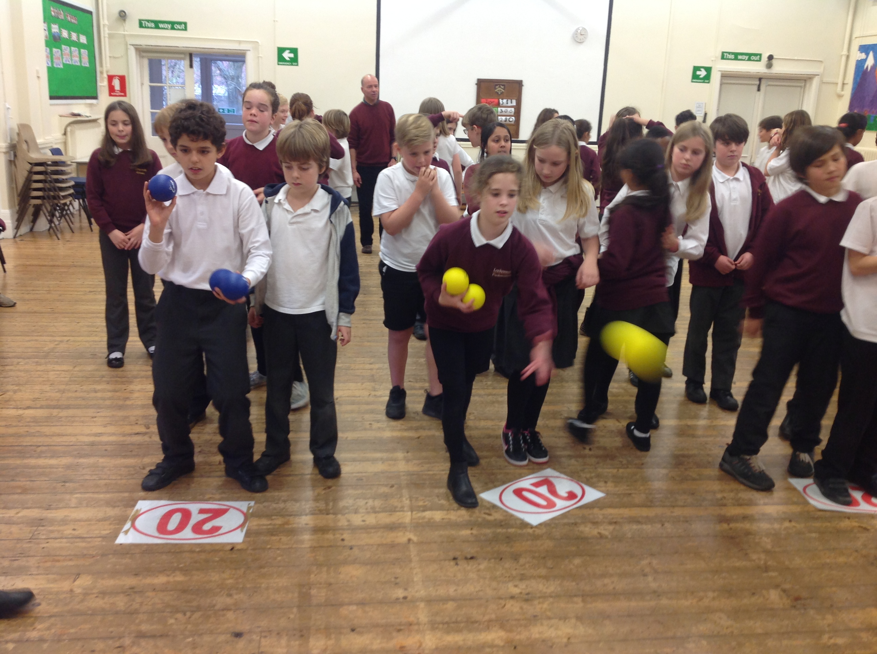
- We can learn anything if we want to
- Learning is about following a step-by-step approach
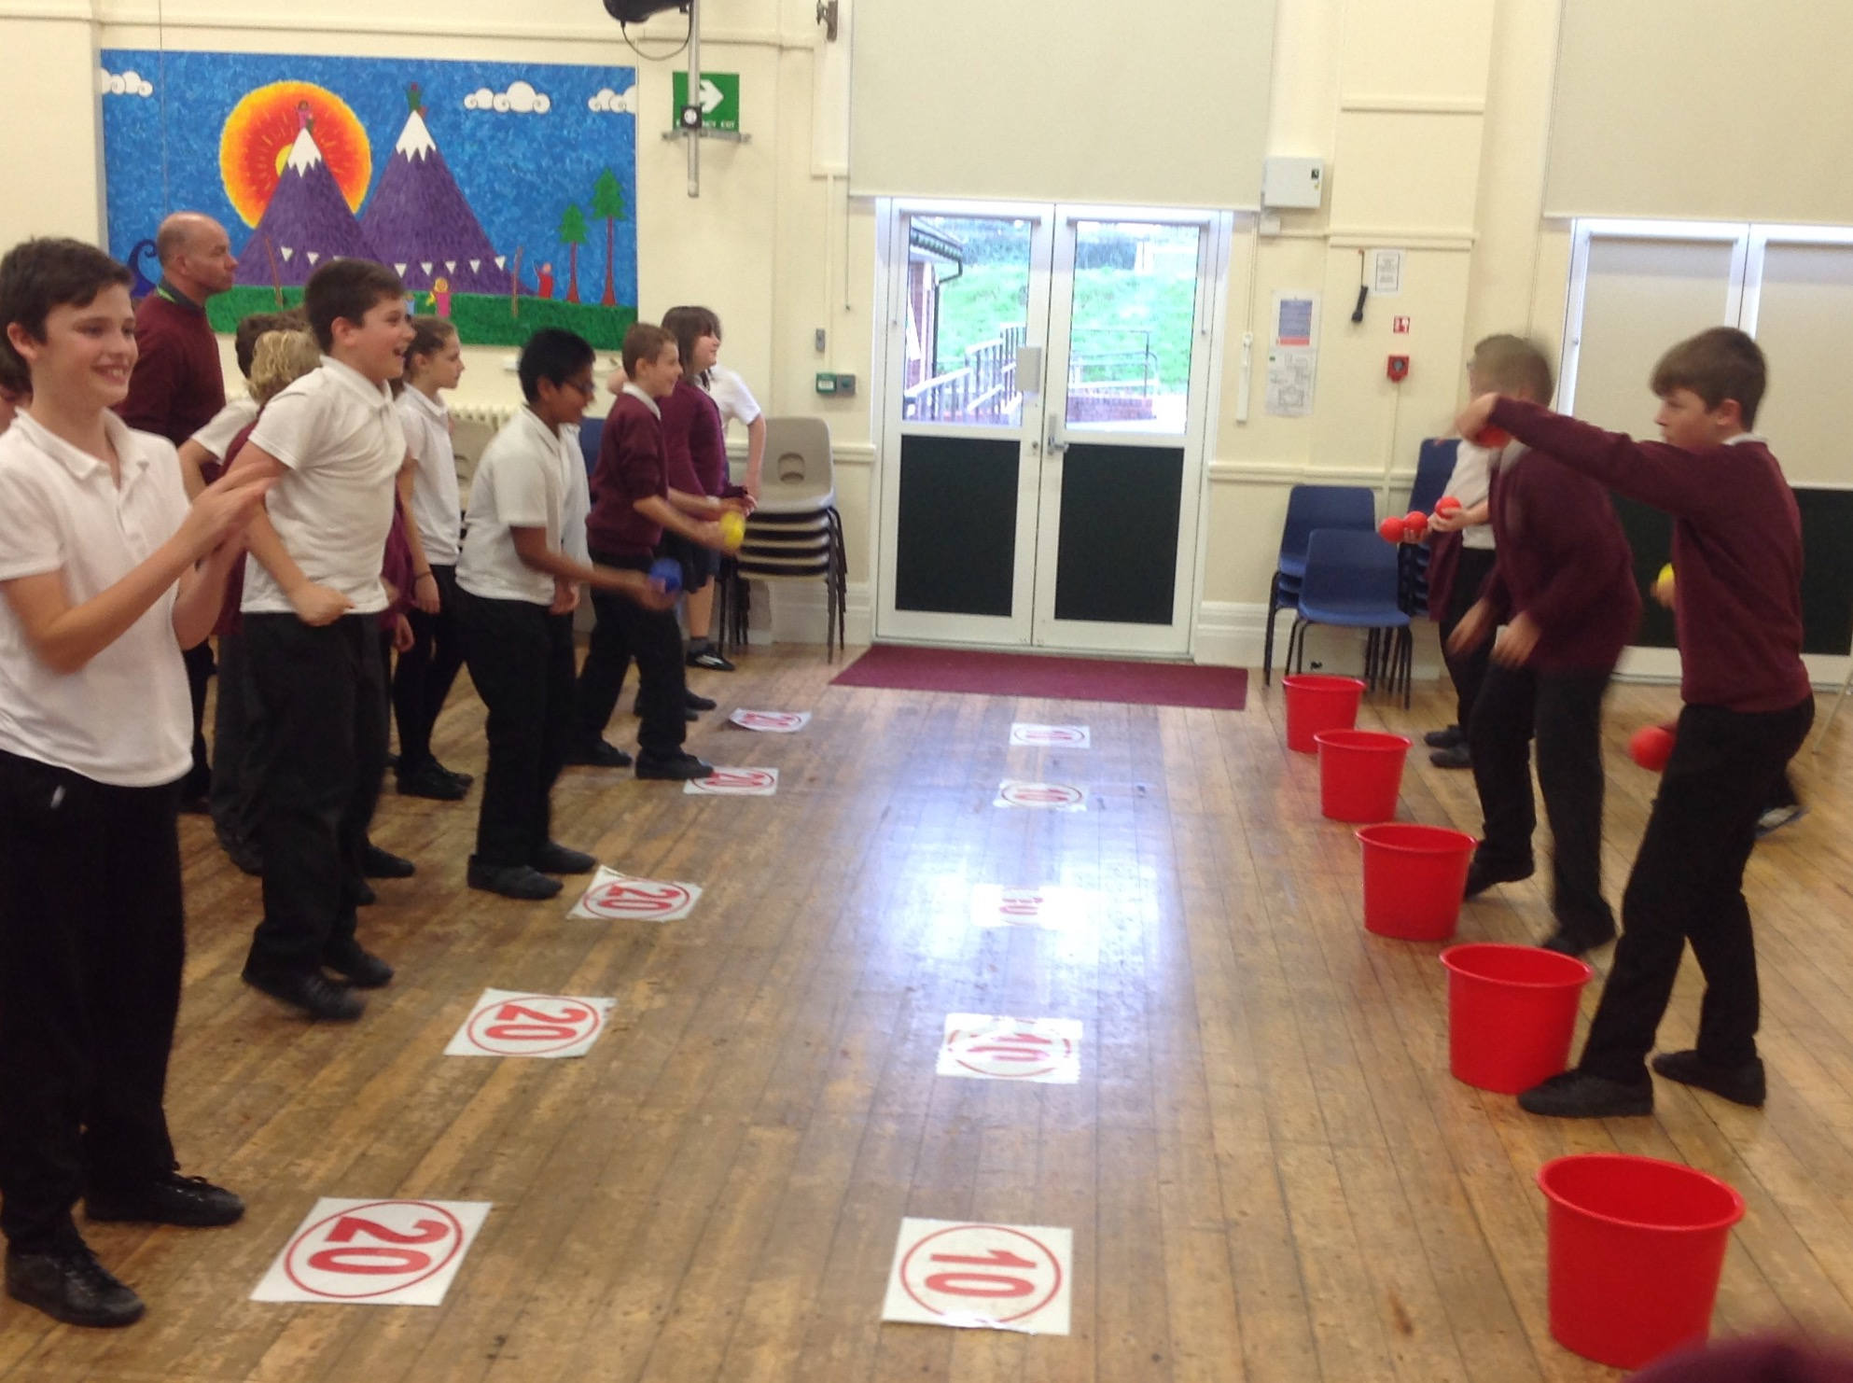
- Getting along with others makes life much easier

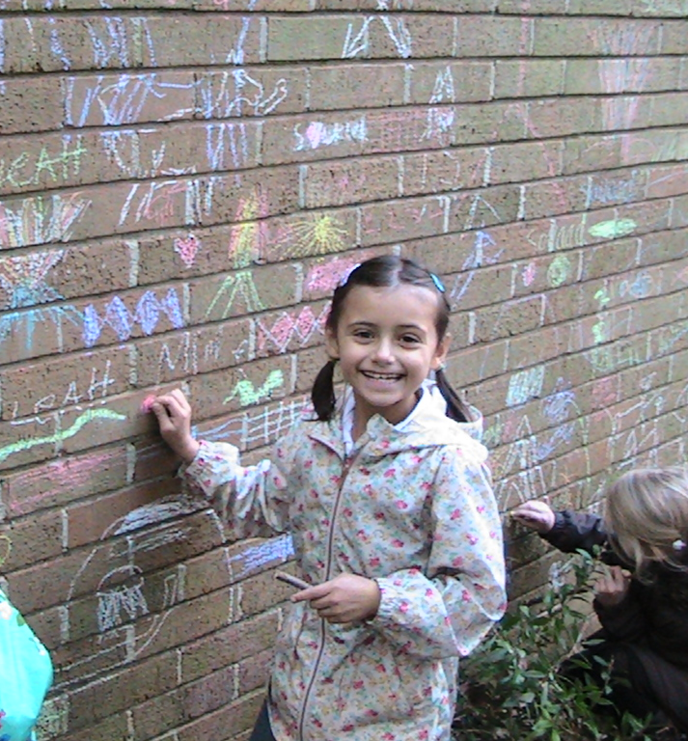
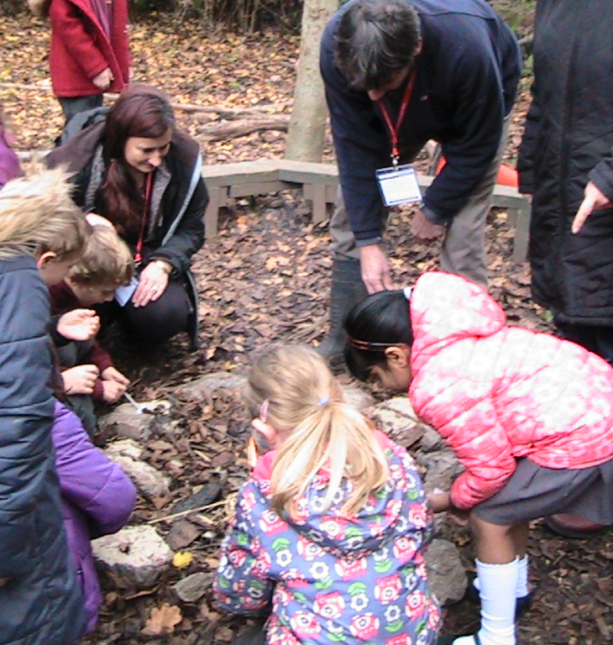
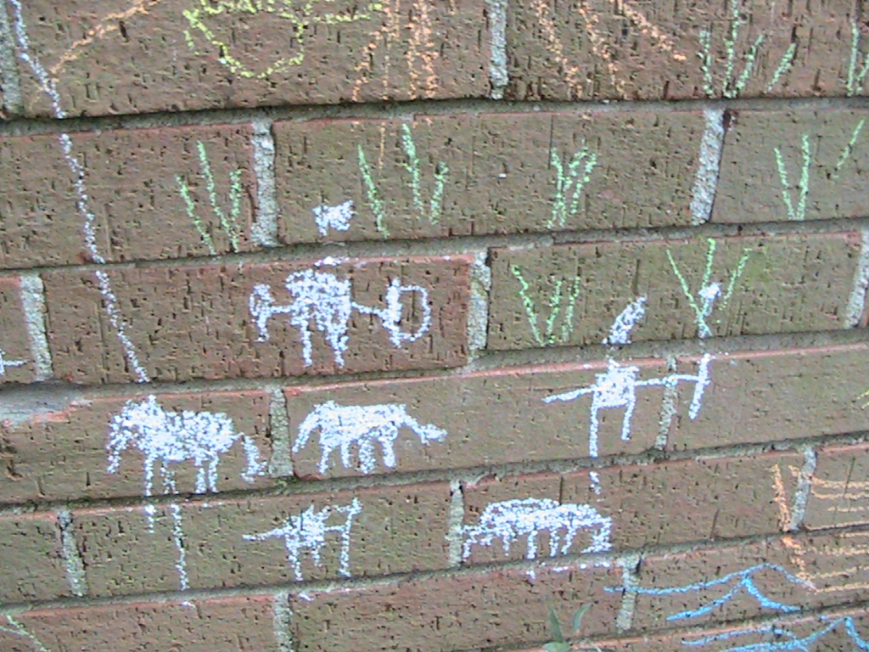
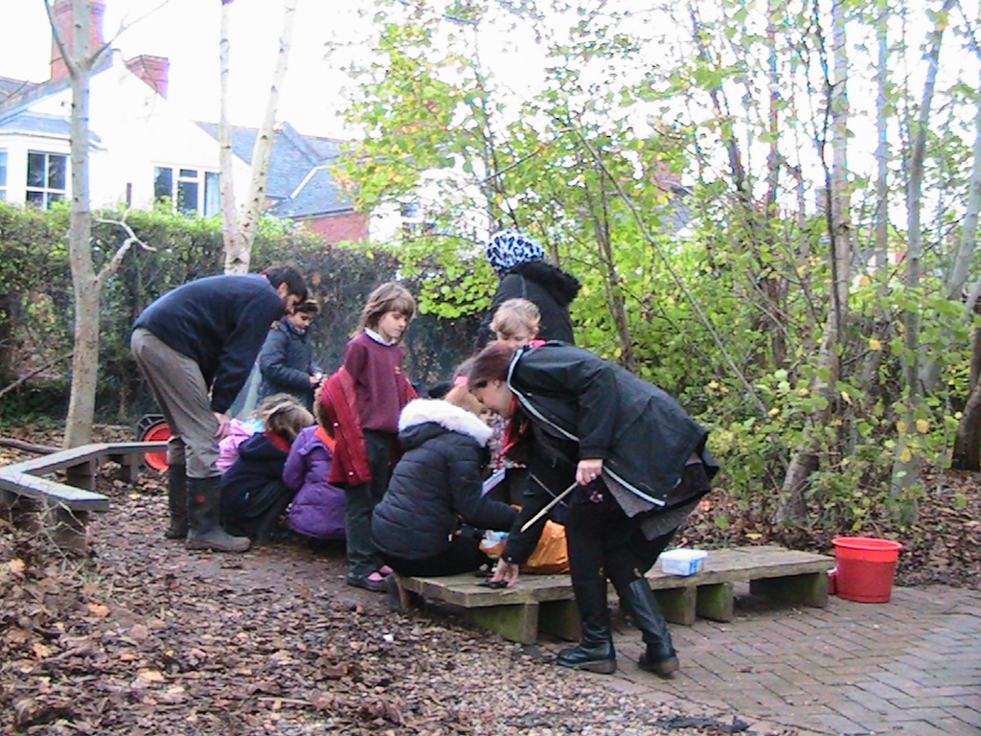
Year 3 Stone Age Experience
Mod cons were out of the window last week when Year 3 took to the Millenium Garden to practise their Stone Age skills. They made fires, sharpened sticks for hunting and told stories of their amazing deeds through cave art. The children had a great time. A huge thank you to all the parents that came in to help.
Class Assemblies
As class assemblies were so successful last year we will be continuing with them this year. Throughout the year each class will take a Friday assembly to show something they have been learning about in class. It is a great opportunity for the children to speak in front of the whole school. Assemblies will start at 9:05 and all family members of the class who are taking the assembly are welcome to come and watch. Assemblies this term are:
3AN – 4th December 3GM – 11th December
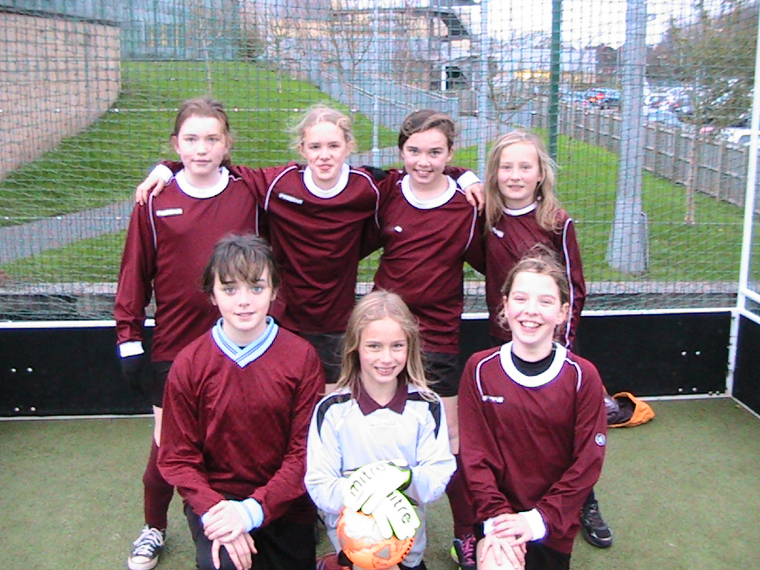
Girls Football
On Wednesday night I was lucky enough to accompany a team of 7 Year 6 girls who took part in a futsal tournament at St Luke’s Science and Sport College. The girls showed fantastic team spirit and represented the school brilliantly. They played 5 matches of which they lost 3 quite narrowly, drew one and won one convincingly. Well done to Izzy, Esme, Hazel, Ellie, Tallulah, Alice and Lisa.
Mixed Hockey
Congratulations to the hockey team who came 3rd out of 6 local schools to claim bronze medals last Friday at St Luke’s Science and Sports College. Special thanks to Ollie from Premier Sports who came along to support the team.

Christmas Disco
The Christmas Disco will take place on Monday 7th December in the Junior School hall. Entry to the disco costs £1.50 and is payable on the door. Times for Years 3&4 are from 6.00pm-7.00pm / Years 5&6 are from 7.30pm-8.30pm.

Christmas Lunch
School Christmas Lunch will be on Wednesday 16th December. The lunch menus for that week will go out on Friday 4th.

The School Nurse Service
You can contact your local School Nurse, Lorraine Crook, by phoning 01392 356051 or by texting Beacon followed by your question to our texting service on 07860 021467. Our team also includes: Gillian Rayner, School Nurse, Annette Sullivan, School Nurse and Sue Dennis, Community Health Worker.
Should you have any questions or concerns regarding your child’s health and how they can be supported in school please contact your School Nurse.
The School Nursing Service are also holding Community Clinics on Wednesdays 2.30-4.30pm at Whipton Children’s Centre.

For more information please pick up a flyer from the Junior School entrance hall.

