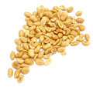
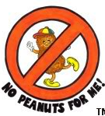
ALLERGIES
It is very important that you tell the school office and class teacher of any allergies your child may have.

PEANUT ALLERGIES
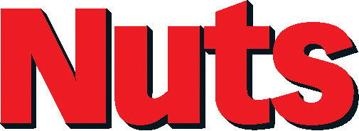

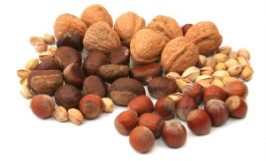
Please do not give your child anything containing nut products in their lunchbox. This includes chocolate snickers bars and peanut butter sandwiches. If your child has a peanut butter sandwich or the like at home before school, please make doubly sure hands are washed thoroughly before attending school. A child can suffer a severe reaction just by someone touching another child who is nut intolerant. The smallest trace can cause a severe reaction!

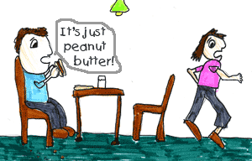

Thank you for caring and helping to keep the children safe.

