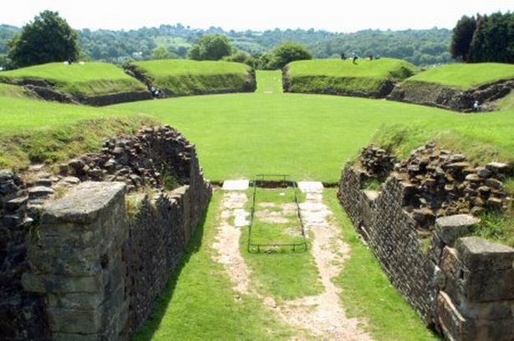
Ladysmith Junior School
Pretoria Road
Exeter
Devon EX1 2PT

Telephone: 01392 255554

Web: www.ladysmithfederation.net
Email: junior.admin@ladysmithfederation.net

Headteacher: Mr Mark Wilkinson

23rd February 2018
Dear Parents and Carers,

We are excited to inform you that on Monday 26th March we will be visiting Caerleon in Wales. Caerleon is the furthest point the Romans ventured west into Wales. It has Roman Baths, a Roman Museum and an impressive natural amphitheatre and barrack remains. This will be a wonderful way to end our Roman topic and a valuable opportunity to look at Roman ruins and artefacts, up close, for real!

Each Year 3 class will take a tour around Caerleon throughout the day which will include a Roman school lesson delivered by staff at the museum. As Caerleon is just over the border into Wales, we will need to leave school at 8:00am promptly. Children will need to arrive at 7.45am and go straight to their classroom. We will aim to return back to school at 5:00 pm.

This is a whole day trip so children will need a hearty packed lunch and plenty to drink. They are not permitted to bring spending money as our day is fully booked with activities. Children will also need to ensure they bring a waterproof coat in case the weather deteriorates throughout the day. Children will need to wear school uniform.

If your child will require travel sickness medication, please provide this in named bags with details of dosage etc.

The total cost of the trip is £12 per child. For children in receipt of the pupil premium grant, the cost is £6.00. If possible, please pay online via ParentMail. If you pay online, you do not need to return this paper permission slip.
Activities / workshops during the day have been funded by the CPTT.

As a final note, on Thursday March 29th, Year 3 will be having a Roman Feast. Children are encouraged to dress up in their finest Roman clothes. This is another ‘tick’ on our ’25 things to do in Year 3’

If you do have any questions or queries, please do come in and speak to one of the Year 3 team.

Many thanks

The Year 3 Team

Trip to Caerleon. Please return to your child’s class teacher or the school office by Friday 16th March. If you pay online, you do not need to return a hard copy of this letter.
Hard copies of this letter are available from reception.

Child: ......................................................................................................... Class: ............................

[ ] I give permission for my child to attend the Caerleon trip on Monday 26th March
[ ] I enclose full payment of £12
[ ] My child is entitled to the Pupil Premium Grant* Therefore, I enclose full payment of £6

*This means that if you are eligible for Free School Meals, the school is in receipt of the Pupil Premium for your child. The Pupil Premium is a fund to support your child’s education financially by making payments and subsidies for a range of learning activities. If you think you are eligible please pick up a leaflet from the reception area or phone: 0845 1551019

Signed: .................................................................... Date: ......................................

