Year 1 Mathematics – What every child needs to know about maths by the end of Year 1
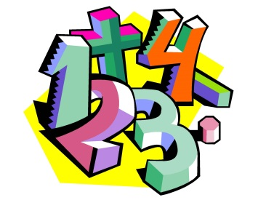

Purpose of study:
Mathematics is a very creative and interconnected subject that can provide the solution to some most intriguing problems. It is essential to everyday life, critical to science, technology and engineering, and necessary for financial literacy and most forms of employment. It therefore provides a foundation for understanding the world and the ability to reason mathematically. Here at Ladysmith Infant and Nursery School we hope to inspire in the children an appreciation of the beauty and excitement of mathematics, and help them to develop a sense of enjoyment and curiosity about the subject.

Curriculum Aims:
- become fluent in the fundamentals of mathematics so that pupils develop conceptual understanding and the ability to recall and apply knowledge rapidly and accurately to a variety of situations
- reason mathematically by following a line of enquiry, thinking about relationships and generalisations, and developing an argument, justification or proof using mathematical language
- can solve problems by applying their mathematics to a variety of routine and non-routine problems with increasing depth, including breaking down problems into a series of simpler steps and persevering in seeking solutions

Assessment:
Assessment of maths in Year 1 is through teacher assessment. In February you will receive your child’s mid–year report which will indicate their progress so far and if they are ‘on track’ to master the maths curriculum.

Mathematics Statutory Requirements:

Number and Place Value

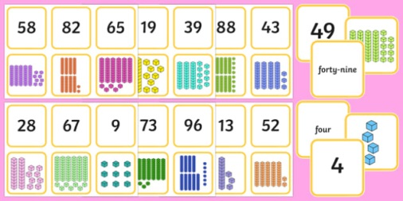

Pupils should be taught to:
- count to and across 100, forwards and backwards, beginning with 0 or 1, or from any given number.
- count, read and write numbers to 100 in numerals; count in multiples of twos, fives and tens
- given a number, identify one more and one less
- identify and represent numbers using objects and pictorial representations including the number line, and use the language of: equal to, more than, less than (fewer), most, least
- read and write numbers from 1 to 20 in numerals and words.

Number—addition and subtraction

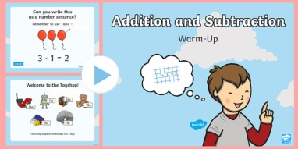

Pupils should be taught to:
- read, write and interpret mathematical statements involving addition (+), subtraction (–) and equals (=) signs
- represent and use number bonds and related subtraction facts within 20
- add and subtract one-digit and two-digit numbers to 20, including zero
- solve one-step problems that involve addition and subtraction, using concrete objects and pictorial representations, and missing number problems such as 7 = [ ] – 9.

Number—multiplication and division
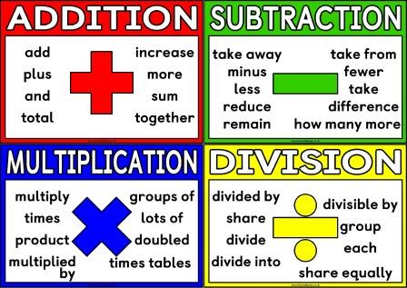

Pupils should be taught to:
- solve one-step problems involving multiplication and division, by calculating the answer using concrete objects, pictorial representations and arrays with the support of the teacher.

Number—fractions
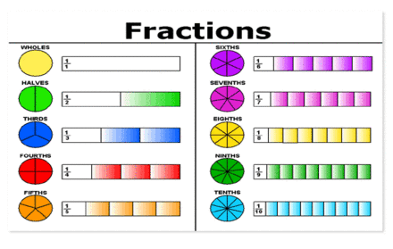

Pupils should be taught to:
- recognise, find and name a half as one of two equal parts of an object, shape or quantity
- recognise, find and name a quarter as one of four equal parts of an object, shape or quantity.

Measurement
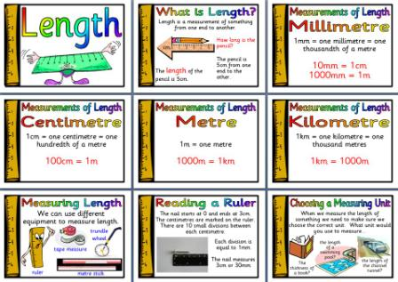

Pupils should be taught to:
- compare, describe and solve practical problems for:
- lengths and heights [for example, long/short, longer/shorter, tall/short, double/half]
- mass/weight [for example, heavy/light, heavier than, lighter than]
- capacity and volume [for example, full/empty, more than, less than, half, half full, quarter]
- time [for example, quicker, slower, earlier, later]
- measure and begin to record the following:
- lengths and heights
- mass/weight
- capacity and volume
- time (hours, minutes, seconds)
- recognise and know the value of different denominations of coins and notes
- sequence events in chronological order using language [for example, before and after, next, first, today, yesterday, tomorrow, morning, afternoon and evening]
- recognise and use language relating to dates, including days of the week, weeks, months and years
- tell the time to the hour and half past the hour and draw the hands on a clock face to show these times.

Geometry—properties of shapes
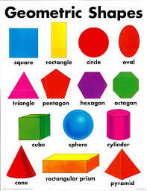

Pupils should be taught to:
- recognise and name common 2-D and 3-D shapes, including:
- 2-D shapes [for example, rectangles (including squares), circles and triangles]
- 3-D shapes [for example, cuboids (including cubes), pyramids and spheres].
.

Geometry—position and direction
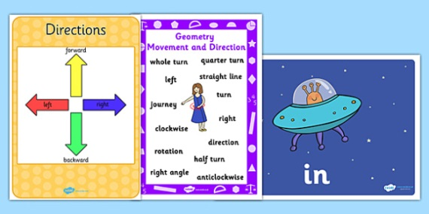

Pupils should be taught to:
- describe position, direction and movement, including whole, half, quarter and three quarter turns.

Supporting your Child at Home

Online Resources:

1. www.bbc.co.uk/education/subjects/zjxhfg8 —no log in
needed. A range of number games and activities can be
found here.
2. https://nrich.maths.org/ - this will take you to their home
page. Then, select ‘Resources for ages 5-7’.
3. http://mathsticks.com/my/tag/ks1-5-7-yrs-2/ - here you will find a range of games and ac-tivities to play with your child.
4. We will be adding some maths games to the Active Learn page (the same one where your child accesses Bug Club.

Something to do…
- Count coins (real/plastic) in multiples of 2, 5 and 10
- Practise counting forwards/backwards in 2s, 3s, 5s and 10s
- e.g. 3,6,9,12,15,18,21,24,27,30 and 30,27,24,21...
- Please see the half-termly curriculum letter for further ideas

