English
- Non-fiction writing about dinosaurs.
- Writing sequence – Dinosaurs and all of that rubbish by Michael Foreman
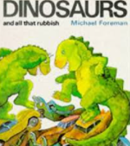
- Phonics – Phase 5b and 5c of Letters and Sounds
- Shared reading – we are focussing on various books to develop a love for reading and comprehension skills.
- Guided reading to apply phonics and reading strategies.
- Learn and retell stories and texts.

Maths
- Measurement. We are exploring capacity, mass and length in different contexts.
- Numbers to 50 – place value and understanding numbers in the number system up to and beyond 50
- Money – setting up a shop and focussing on using our adding and subtracting skills and the relationship between + and – (eg. knowing that 4 + 3 = 7 so 7-3=4).

Year 1 Curriculum Spring Term 2021
Dinosaurs
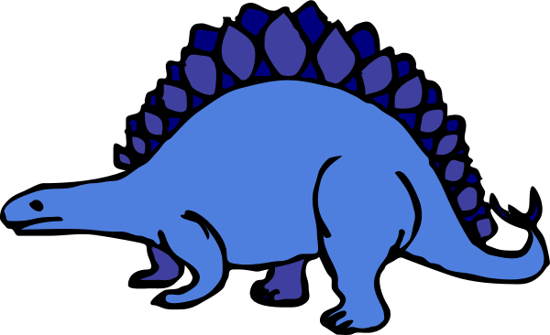
- Hook: We will go back in time to discover dinosaurs. A day of dinosaur related investigations. Children to come dressed in home clothes ready for Forest School on Tuesday 23rd February 20212.

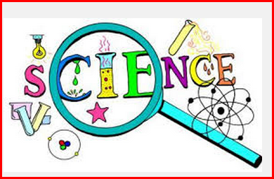
Science
- Forest School
- Seasonal changes and weather – focus on ‘The Herald of Spring’ finding seasonal flowers and pressing them
- Investigate the different food eaten by dinosaurs – simple food chains, herbivores, omnivores, carnivores
- Compare how different dinosaurs moved
- Identify and name different types of trees

Humanities
- Dinosaurs in their habitats – where did they live?
- The life of Mary Anning
- Why Mary Anning is still remembered today
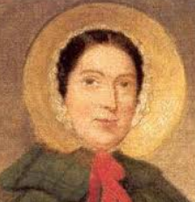

PE
- Gymnastics
- Dance and movement – dinosaur stomp

Art and Music
- 3D sculpture: children will be planning, making and evaluating a clay dinosaur
- 3D dinosaurs 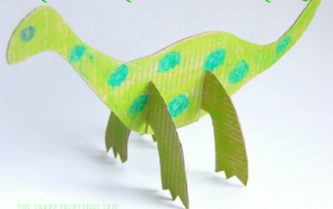
- Dinosaur silhouettes
- Dragon puppets
- Simple composition using un-tuned instruments

