**PRIME AREAS**



In Personal and Social Education we will be:

* Looking at the wider world and stories that reflect similarities and differences.
* Learning about relationships with our friends and respecting their thoughts and feelings.
* Thinking and talking about feelings, our own and others.
* Solving problems and compromise.



In Physical development we will be:

* Joining in with aerobic activities including “Go-Noodle” as a class.
* Developing cooperation in team games and working together.
* Developing our ball skills, tracking and target skills and skipping skills.
* Learning the importance of using equipment safely and keeping it under control.



In Communication and Language we will be developing our speaking and listening skills, attention and understanding through:

* Listening to and discussing a vast range of stories and texts from around the world.
* Learning stories by heart and acting them out.
* Talking about our learning using the animal characters.
* Asking questions and responding in an appropriate way.



**Journeys by land**

**and air.**

**Reception Summer Term 1 Overview**

Characteristics of Effective Learning focus:-

This term we will be focusing in on a different characteristic each week. As a class we will choose which one to look out for specifically and remind the children that:-

This week I am really looking for a…

Please see each class teacher if you would like an update on the focus for the week.

*Please ask if you are not sure what the animals represent or how we use them. We’d love your views on how your child takes on these characteristics as he/she plays and learns.*

**SPECIFIC AREAS**

-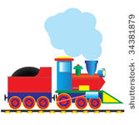

In Literacy we will be:

* Learning the story of “The Train Ride” by heart.
* Consolidating our phonic knowledge and extending our ‘decodable/tricky word’ knowledge.
* Practising to write ‘decodable/tricky words’ by heart.
* Labelling pictures, making story maps, making books, writing labels, captions and simple sentences.
* Encouraging the children to write ‘Golden Sentences’

(starting with a capital letter, having finger spaces between words and finishing with a full stop).

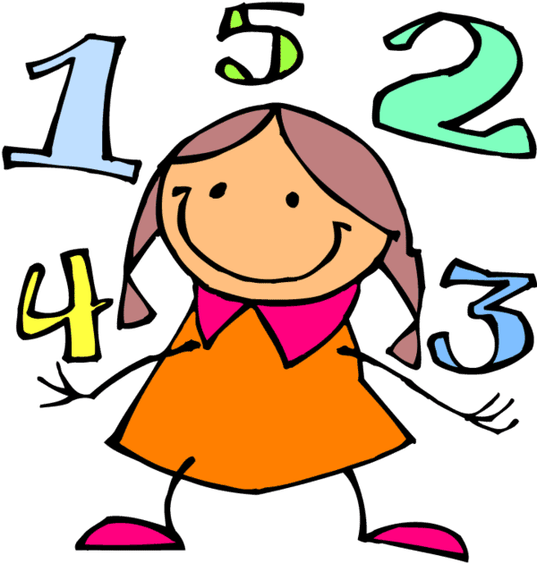

In Mathematics we will be:

* Recognising and ordering numbers 0 to 20.
* Simple addition and subtraction within those numbers.
* Counting in 2s, 5s and 10s.
* Looking at and discussing shapes we may see on our journeys.
* Looking at problem solving by sharing.

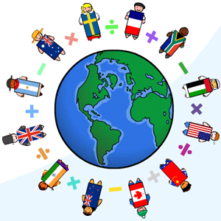

In Understanding the World we will be:

* Discussing our experiences of different journeys.
* Finding out/exploring different environments.
* Looking at different environments and discussing them.
* Looking at changes from a caterpillar to a butterfly.

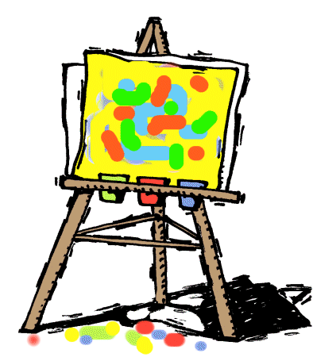

In Expressive Arts and Design we will be.

* Creating a collaborative village/town out of boxes.
* Exploring how to use different tools safely and effectively.
* Looking at and learning how to create different landscape pictures.
* Using different percussion instruments to represent journeys and extend our repertoire of songs.