NEWS AND CELEBRATIONS

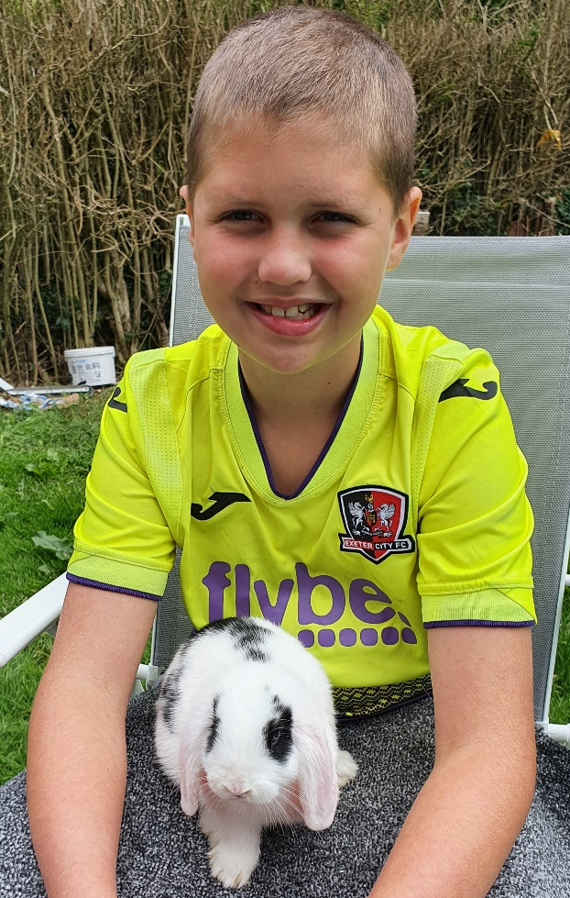 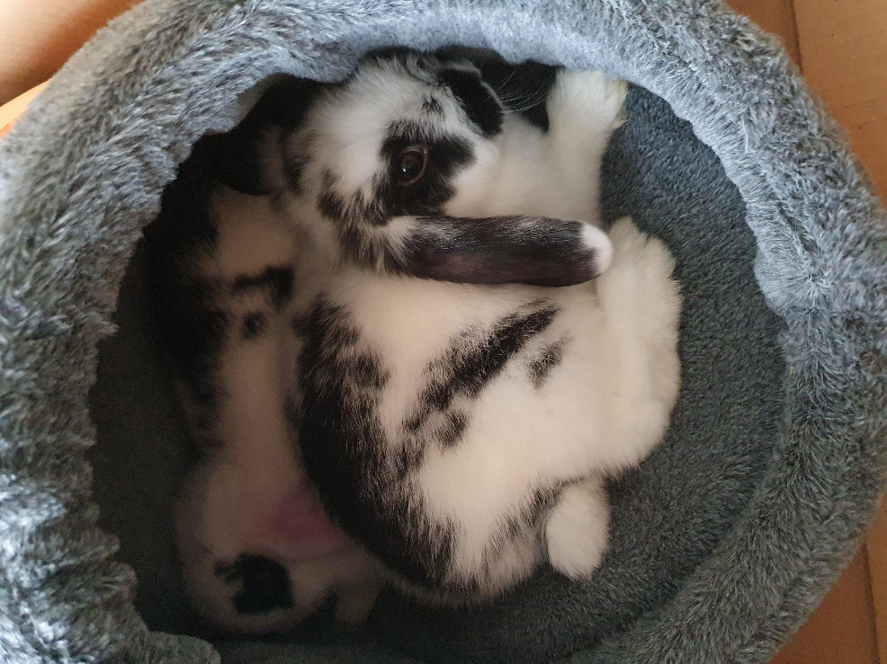

**Logan and his family gained two new members this week (Willow and Benji)! I think you will agree that they are super cute!**

**Harry has been busy practising trick shots! You can see how he is getting on here** [**https://www.youtube.com/watch?v=d8MnAvVmn2I**](https://www.youtube.com/watch?v=d8MnAvVmn2I)

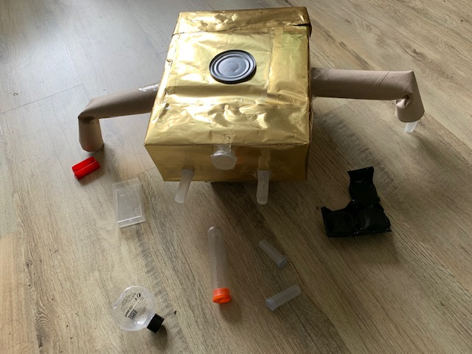

**We really loved Lucas’ robot creation. It is called ‘Binny’ and eats plastic which also fuels it! Great job, Lucas!**

**Luke (5MS) created some beautifully descriptive sentences while exploring curves in nature. Well done, Luke!**

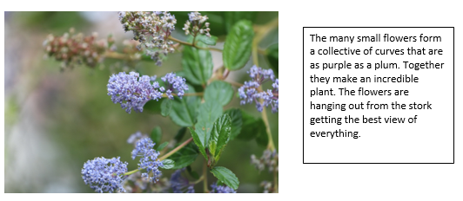



**Alexander (5LD) enjoyed has been busy creating funky curves showing the pursuit of predatory bugs! How awesome are these?!**

