**SPECIFIC AREAS**



In Literacy we will be:

* Finding out about the Oxford reading tree characters
* Learning the story of “The Three Billy Goats Gruff” by heart
* Learning to recognise, say, write and blend phonemes (letter sounds)
* Labelling pictures of our families and writing speech bubbles

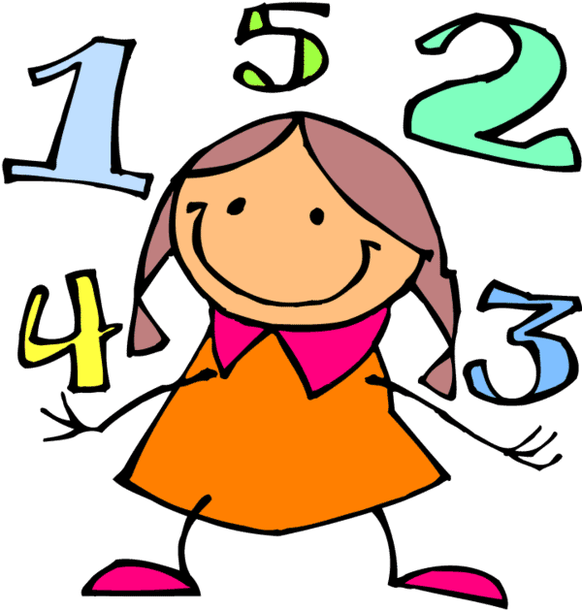

In Mathematics we will be:

* Learning to play number games and puzzles and singing number songs
* Ordering family members by height and finding people who are taller or shorter than us.
* Looking at patterns with shapes and repeating patterns.
* Ordering and comparing characters from our stories and using positional and directional language when acting out “The Three Billy Goats Gruff”



Understanding the World through:

* Knowing what make us happy and sad
* Finding out about our favourite foods
* Finding out about the family members of our friends
* Learning about special places and celebrations

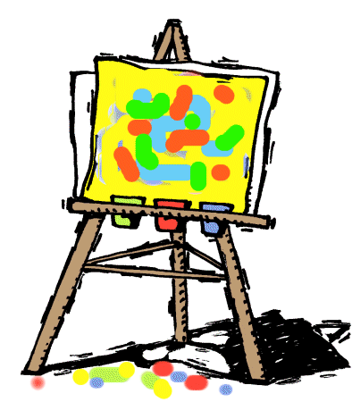

Expressive Arts and Design

* Creating self-portraits.
* Exploring percussion instruments and how to keep a beat, follow a repeating pattern.
* Learning how to use tools correctly to create effects



**Knowing me, knowing you…**

**Reception**

**2016 Autumn Term Overview**

Focus on the Characteristics of Learning:

**19.9.16 - Curious Cat**

(Finding out and exploring)

**26.9.16 - Curious Cat**

(Finding out and exploring)

**3.10.16 - Can-do-bird**

(Being willing to have a go)

**10.10.16 - Can-do-bird**

(Being willing to have a go)

**17.10.16 - Persevering Bear**

(Keeping on trying)

*Please ask if you are not sure what the animals represent or how we use them. We’d love your views on how your child takes on these characteristics as he/she plays and learns.*

**PRIME AREAS**



In Personal and Social Education we will be:

* Learning how to make someone feel welcome,
* Making sure that people around us are happy,
* Think about our feelings,
* Solving problems,
* Listening to others before speaking
* Helping to cheer someone up



In Physical development we will be:

* Joining in with aerobic activities including “Go-Noodle” as a class
* Developing gross motor skills through using large wheeled vehicles, tools and equipment
* Developing fine motor skills through extending our core strength, pincer grips and joining in with “funky fingers” and “dough gym” activities



In Communication and Language we will be developing our speaking and listening skills, attention and understanding through:

* Listening to and discussing a vast range of stories and texts
* Learning stories by heart and acting them out
* Talking about our learning using the animal characters
* Extending our attention span gradually