Calculation Policy – Addition and Subtraction
November 2018

John Holt says: A pupil understands a mathematical concept, idea or technique if he or she can:
- describe it in his or her own words;
- represent it in a variety of ways (e.g. using concrete materials, pictures and symbols);
- explain it to someone else; make up his or her own examples;
- see connections between it and other facts or ideas;
- recognise it in new contexts or situations;
make use of it in various ways.
These beliefs underpin our teaching and assessment of mathematical understanding at Ladysmith Infant and Nursery School.

Foundation Stage

Number

A key priority of any Primary School maths curriculum is to ensure that children develop a strong sense of number and place value. Children will continually encounter numbers in the world this morning or on their front door at home. But the ability to recognise the symbol 5, and name it, is very different from understanding the ‘fiveness’ of it, and it is the development of this latter skill that is crucial to a child’s mathematical ability.

Furthermore, it is important to recognise that just because a child can recite number names in order, does not necessarily mean that they can count. As with learning the alphabet, children can recall a sequence of numbers by rote without any real grasp or understanding of what they mean (hence young children often omit numbers as they count). Gaining familiarity with number names through songs and rhymes is of course helpful, but emphasis should be placed on helping children make links between these number names and the number of objects they equate to.
An intuitive sense of number begins at a very early age, and even before they start school, many children can identify one, two or three objects in a group, regardless of whether they can count. This ability to instantly compute the total in a small group of objects derives from stable, mental images of number which have developed over time from a variety of experiences with different patterns of number. For example, a child might immediately recognise the 6 on a dice, domino piece or playing card:

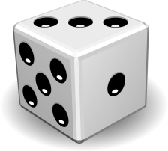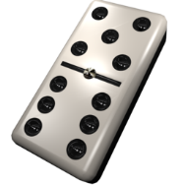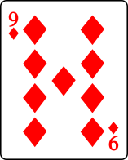

It is possible that the child has memorised this familiar arrangement of 6 dots. Alternatively, they may have mentally sub-grouped them into two sets of 3, fostering an understanding that a number can be composed of smaller parts. In both cases, no actual counting of objects is involved; instead, the child has relied on other mental strategies.
In the Foundation Stage, as well as teaching the children to count objects, significant attention is given to cultivating number recognition and the development of mental representations. In order to do this, much of their experience with number play in the early years will involve concrete, movable objects.

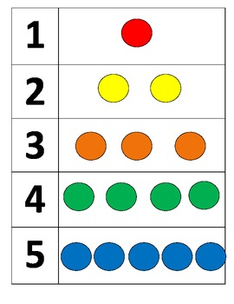

Use of numicon is another great way to help children develop mental representations of number.

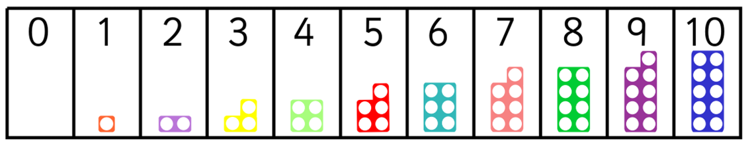

These experiences and number representations will help children:
- Reliably count the number of objects in a set using the numbers one to twenty.

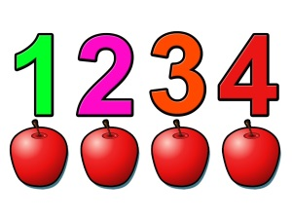
- Place numbers in order.
Numicon, in particular, helps children to visualize how the size of numbers relate to each other.

- Say which number is one more or one less than a given number.
What is one less than five?

5 4
five four

- Use objects to add two single digit numbers by counting on to find the answer.

4 5 6 7
4 + 3 = 7
- Use objects to subtract two single-digit numbers by counting back to find the answer.

The first step into subtraction is to learn to count backwards.

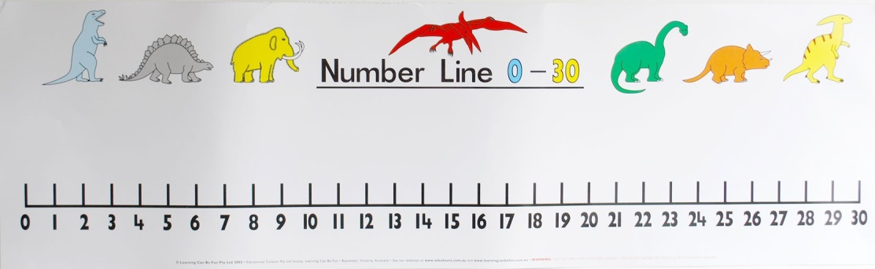
Let’s count back from 14!

Children will then utilize this strategy to solve simple subtractions.
4 – 3 = 1
There were four ladybirds on a leaf. How many will be left if three fly away?

4

3

2

1

Year 1 – Addition and Subtraction
Video clips:
Using a range of equipment to reinforce addition and subtraction strategies.
https://www.youtube.com/watch?v=OkW1Y11tGxw&list=PLQqF8sn28L9wjDm8uJEJcRCDDoY6raPE_

Children are expected to:

- Represent and use number bonds and related subtraction facts within 20.
Once a basic number sense has developed for the numbers up to ten (see the Foundation Stage section of the calculation policy), children must establish a strong sense of ‘ten’. Children will become familiar with the ‘tenness’ of ten using a variety of practical resources:

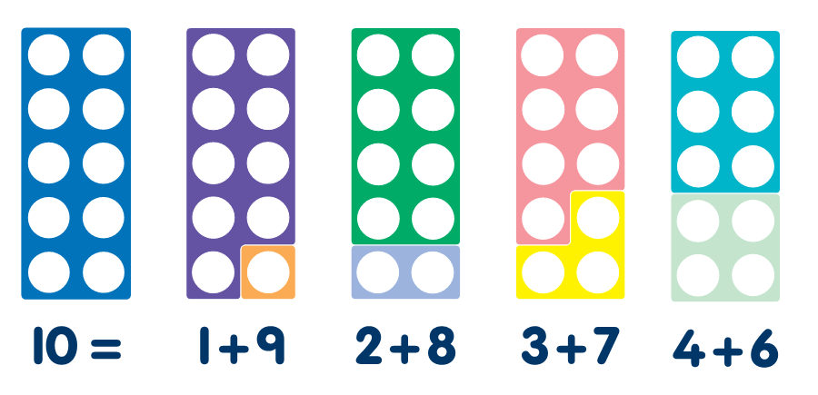

Children should also be made familiar with the related subtraction facts.

10 – 0 = 10 10 – 1 = 9 10 – 2 = 8 10 – 3 = 3 etc
Ten Frames:
A ten frame, like the one below, is a great tool for embedding an understanding of ten. By placing counters in different arrangements on the frame, children can begin to generate various mental images of the number ten, as well as how other numbers relate to it.

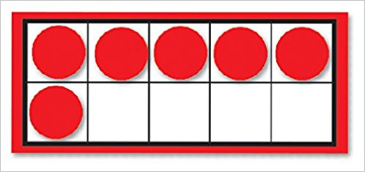

“There are six counters. I need four more to make 10”

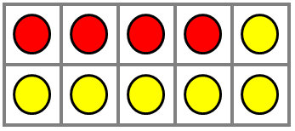

“Six and four make ten.”
“ I have ten counters. If I take four away, I will have six left. If I take six away, I will have four left.”

A knowledge of number bonds is not just about knowing how to make the numbers 10 and 20. Children should also start to investigate ways to make other numbers less than 20. Several resources can aid this learning:
Numicon:
“What numicon pieces can help me make the number 5 and find out the related subtraction facts?”
4 + 1 = 5
5 – 1 = 4
5 – 4 = 1
The concrete or pictorial representations of number facts should always be linked to the abstract (i.e. the number sentence it relates to).

Double sided counters can be used to help children find out about different ways of asking the same number. They may also start to spot patterns.
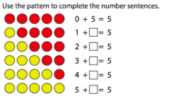
“Can you use these to help you write some subtraction number sentences?”
‘Part Part Whole’ model allows children to visualize the concept that numbers are made up of two or more parts (i.e. other numbers).
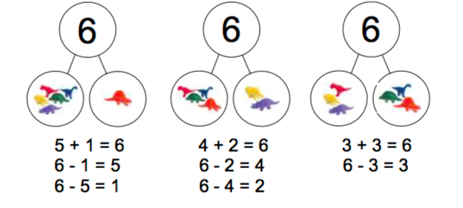

Ten Frames and numicon resources can naturally lead the eye to addition concepts.
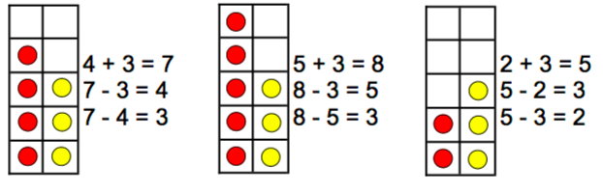
They can also help children visualize addition doubles:
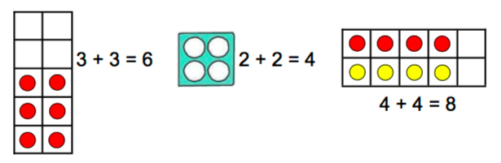
Furthermore, Numicon and ten-frame resources can provide the first step into understanding 2 digit numbers. By using two ten-frames simultaneously, children can start to see the value of each digit in a ‘teen’ number.

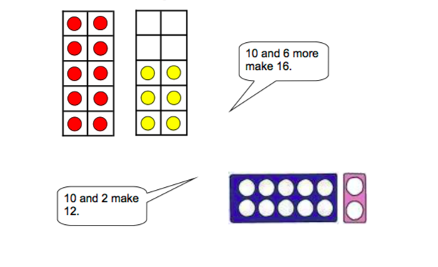
It will also be helpful, at this stage, to introduce the children to Base 10 resources and use them to partition ‘teen’ numbers into tens and units.

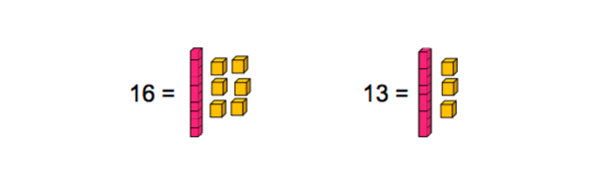
Through all of the above, children should start to recognize the relationship between addition and subtraction facts.

- Identity on more or one less than a given number.
With visual representations to support them, children should be able to tell you what is one more or one less than any given number.

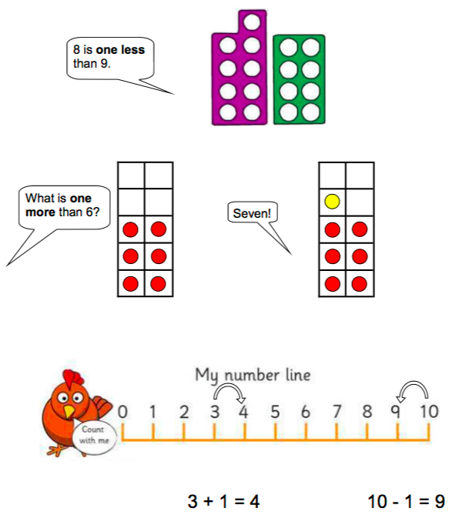

- Add and subtract any one-digit number or two-digit number up to (and including) 20.
We have already seen how children can start to understand addition as combining groups. To help them work out the total of two numbers, children may initially count them up. Once again, concrete, movable objects will support this process.

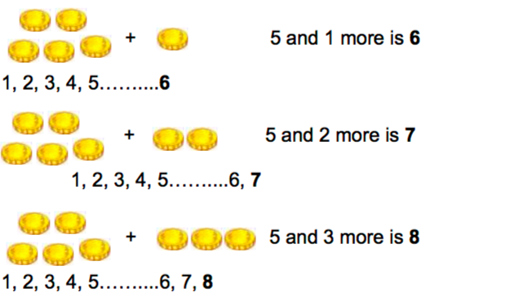

Eventually, as children become more competent, they will be able to hold the biggest number in their head and then count on – perhaps using their fingers – from there. Using two sets of dice, one with digits and another with dots, is a great way to encourage children to practice this skill.
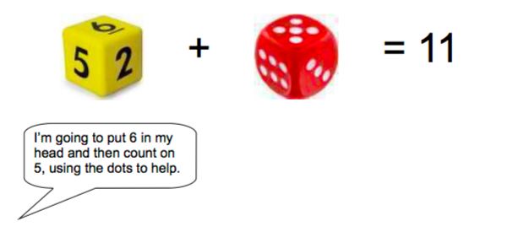

They will also begin to use a number line to add or subtract numbers.

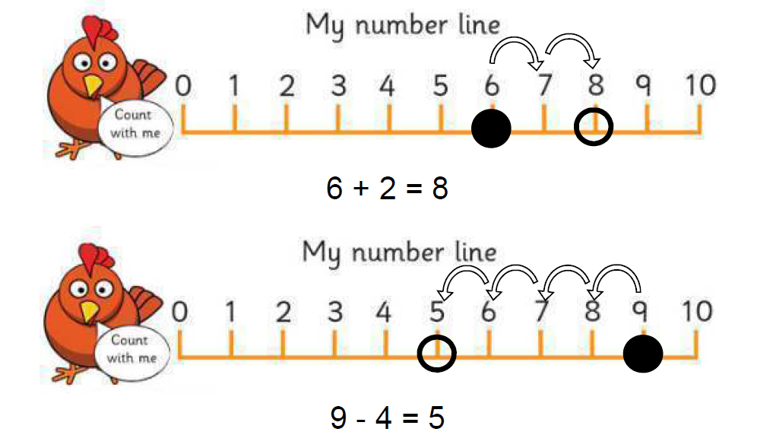

Through these processes, children should start to understand that addition makes number bigger whilst subtraction makes numbers smaller.

They should also recognize that they can add numbers in any order and still get the same answer.

Ten-frames will help the children visualize what is happening when they add two numbers that bridge through 10.

For example, with the calculation 7 + 5 = ? children will begin to identify the opportunity to make 10 first, and then add the remainder.

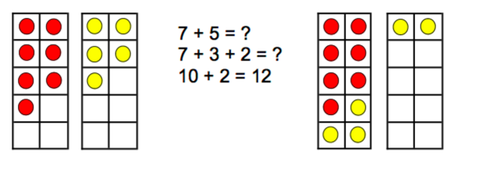

Children should begin to understand subtraction as both taking away and finding the difference between.

A simple bar model can help them get to grips with the latter.

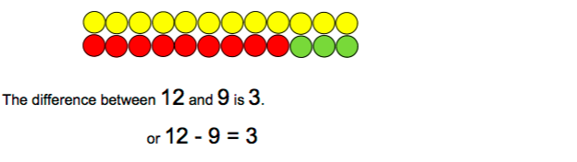

This model is introduced using concrete objects first (including cards with pictures), which the children can move, before progressing to pictorial representations.

- Understand that the equals sign (=) is a sign of equivalence.
Many children develop the misconception that the answer to a calculation is on the right hand side of the equals sign. Scales can be used to help children to explore the idea that both sides of a calculation must balance.

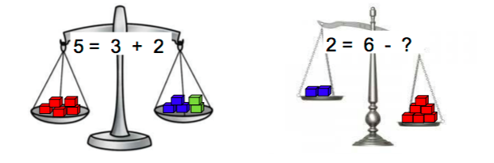

It is important that the children experience the equals sign (=) in different positions. By writing calculations either side of the equals sign (e.g. 2 + 4 = 5 + 1) the children will understand not just interpret it as meaning ‘the answer’.

Through all of this, the children should start to see that addition and subtraction are related operations.

For example, 7 + 3 = 10 is related to 7 = 10 – 3

This understanding can be supported using a tens frame:
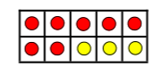
- Solve missing number problems.
Children must be able to complete missing number problems, where the ‘missing number’ can be placed in all possible positions:

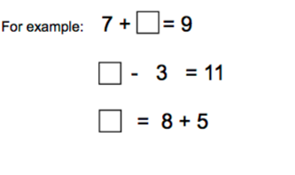

- Vocabulary
Addition, add, forwards, put together, more than, total, altogether, distance between, equals = same as, pattern odd, even, digit, counting on, subtraction, subtract, take away, minus, less than, most, least.

Year 2 Addition and Subtraction

Children are expected to:

- Recall addition and subtraction number facts to 20 fluently.
In Year 1, a great deal of emphasis is placed on generating different mental images and internal representations of number, with a view to build up a bank of facts about them. In order to achieve this, a wide variety of concrete and pictorial resources (please see the Year 1 calculation policy for more details) are used to support the children’s investigations.
The expectation in Year 2 is that children should now be able to recall these number facts to 20 from memory, no longer requiring concrete resources to support them.

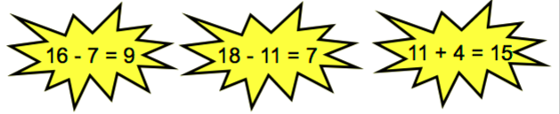

- Use these addition and subtraction facts to 20 to derive facts to 100.
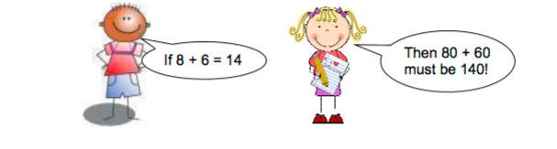

- Add or subtract a 2-digit number and ones. Following on from Year 1, multiple ten-frames can be used as a starting point to add a single-digit number to a 2-digit number.

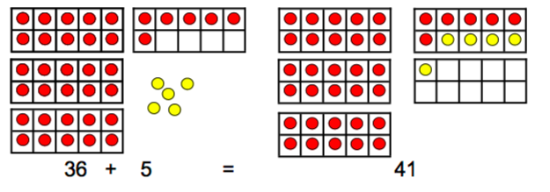

As a child’s number knowledge develops, they will begin to use their known number facts to help them solve calculations mentally.

For example, you could present a child with the following calculation:

Children can use the same strategy on a number line.
67 + 7 = ?
The child recalls a known fact by partitioning the 7 into 3 and 4 first and then:
Add or subtract a 2-digit number and tens. Ten-frames, base 10 and Numicon are all useful resources to help children build on their conceptual understanding of place value and adding on tens.
By placing the ‘units’ frame to the right of the others, you will reinforce their understanding of place value.

These examples clearly illustrate to the children that when you are adding or taking
away tens alone, the number of units remains unchanged.
Once children have grasped this concept using concrete resources, they can move on to using more abstract, pictorial representations.
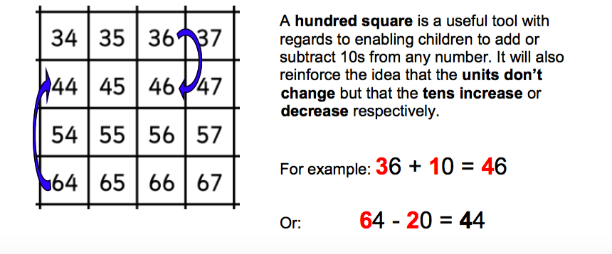

Children can also use this knowledge to help them add or subtract 9 or 11, by adding/ subtracting 10 and then adjusting by 1.
So
54 + 9 = ?
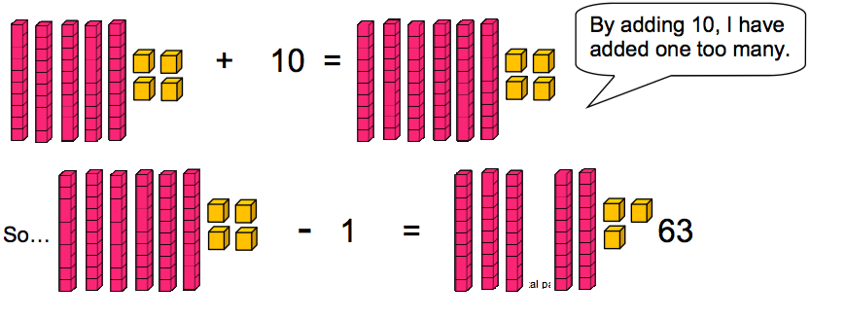
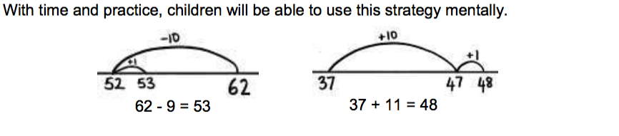

• Add or subtract two 2-digit numbers Initially, the children might use base 10 resources to partition the numbers into their tens and units and then add them separately.
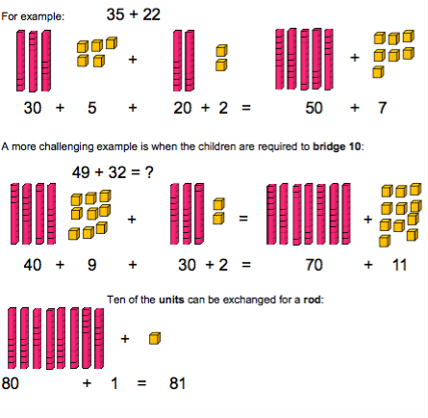

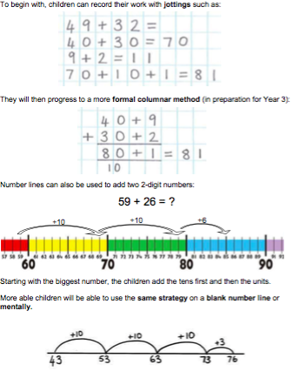
Subtraction calculations can also be carried out using base 10 resources:
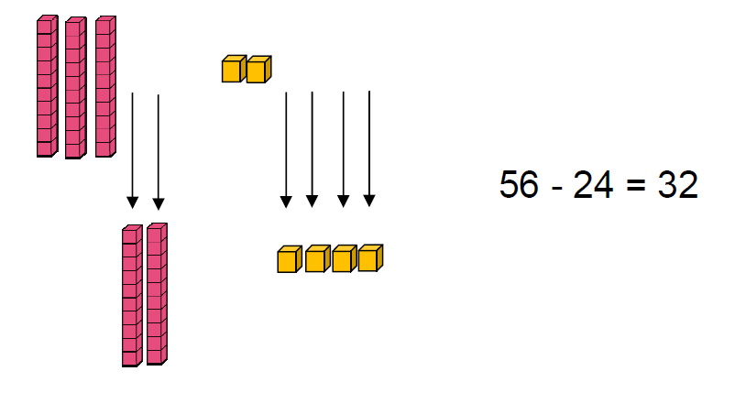
Children will record their workings informally to start with.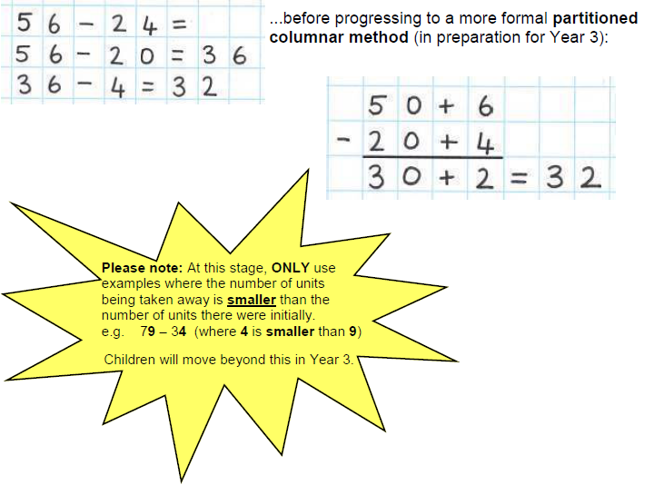

Children can solve subtraction calculations on a number line in the same way; they start on the biggest number and then take away the tens, followed by the units.
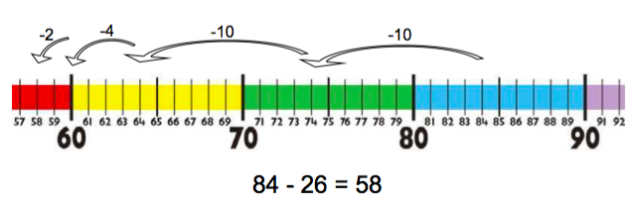

This can also be done on a blank number line or mentally:
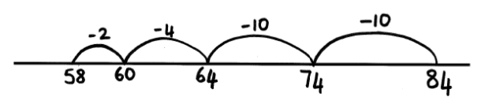

The children are also taught to understand that a subtraction calculation can be solved by finding the difference between two numbers.
The difference between two numbers can be calculated by counting up from the smaller number to the bigger one.
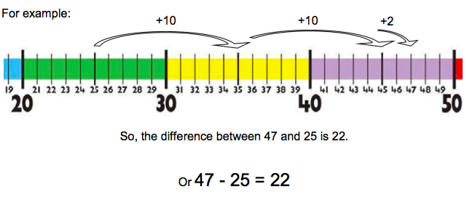

• Add three 1-digit numbers. Children should use a number line or known number facts to help them.
6+8+5
They may want to change the order of the calculation so that they are able to use facts they are more certain of first. For instance, they may do:
6 + 5 = 11 11 + 8 = 19
- Know that the addition of two numbers can be done in any order (commutative) but that subtraction cannot.
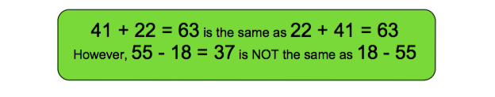

  - Recognise and use the inverse relationship between addition and subtraction and use this to check calculations and solve missing number problems.
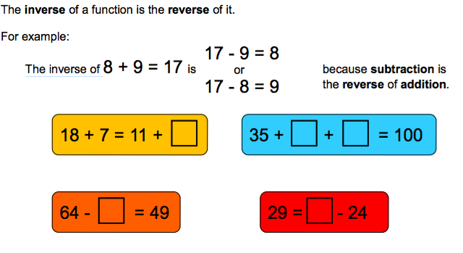
• Solve problems with addition and subtraction, applying their increasing knowledge of mental and written methods.

In particular, children should be given the opportunity to explore the pattern derived from adding odd and even numbers.
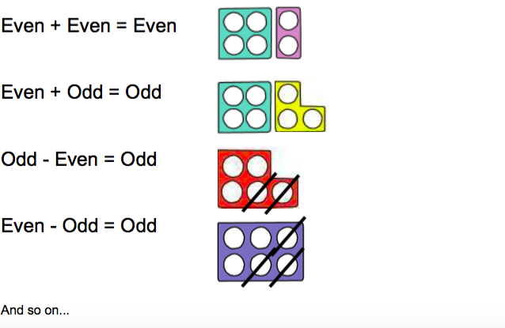

• Vocabulary +, add, addition, more, plus, make, sum, total, altogether, how many more to make ? how many more is than ? how much more is ? =, equals, sign, is the same as, tens, units, partition, multiple of 10, tens boundary, more than, one more, two more ten more one hundred more, -, subtraction, subtract, take away, difference, difference between, minus, less than, one less, two less ten less one hundred less

