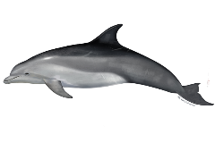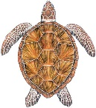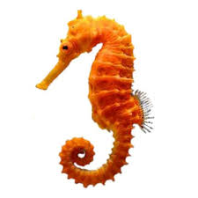

**Computing**

* Programming with Pixie robots.
* Typing skills.
* Using art programmes to create calendars.
* Online safety.
* Ask me how I stay safe online.

**Art and DT**

* Learning about observational drawings and how to use different types of drawing including water colours and powder paints to mix shades.
* Making clay diva lamps
* Can you ask me to draw you an observational drawing of my class animal? Can I name the body parts?

**History**

As part of our wish to have a diverse and inclusive curriculum, we are learning about several significant individuals from history and modern times. Can your child tell you about any of these people and what they did that makes them special?

Rosa Parks David Attenborough Jesse Owens

Rudolf Nureyev Frida Kahlo Mother Teresa

Ada Lovelace Mahatma Gandhi

**PSHE**

We are learning about a range of emotions; how to recognise them, name then and talk about them. We are covering happiness, sadness and worry through stories and activities, learning the vocabulary associated with these emotions. If you would like more information about how we talk to your children about these feelings, please speak to your child’s teacher

**PE**

* Games: simple team games, building core strength and developing co-ordination
* Yoga – enjoy Yoga stories about our class animals whilst stretching our bodies and holding balances to aid our gross motor skills.
* What games have you created with Mr Radford?

**Science**

* Learning about different habitats and what ocean animals need to survive.
* Learning about the properties of different materials and what they are most suitable for.
* Ask me what material I chose for my diver’s suit!

**Geography**

* Learning the names of the seven continents and five oceans of the world.
* See if I can name the oceans and continents and tell you where my class animal can be found.

**English**

* Focusing on joining our letters using cursive script.
* Learning about class animals and writing an information poster all about them.
* Reading and retelling the story of Duffy’s Lucky Escape.
* Enjoying whole class stories and non-fiction books.
* Can you help your child to read and write the Year 2 words? Please also check that they know the Year 1 words too.
* Ask me to tell you the story of Duffy’s Lucky Escape.

**Maths**

* Looking at Place Value and how this can help with addition and subtraction.
* Understand and use mathematical language (more, less, most, fewest, tens, ones, place value)
* Partitioning 2-digit numbers in different ways.
* Addition of 2-digit numbers.
* Telling the time, starting with o’clock and half past times.
* Counting in steps of 10 from any number.
* Ask me to add and subtract simple sums and explain how many tens and ones are in different two digit numbers.

Here are some of the things we are covering this term and some ideas of what you could ask your child about to hear more about their learning journey.

Autumn term in Year 2