


Reception Newsletter
Dear Parents and Carers,
We have had a lovely start to the year, thank you for all your help and support so far. Hopefully everyone has had their Tapestry access email by now – if you haven’t please speak to your child’s class teacher. We are very excited to be sharing their online learning journals with you. We hope you are enjoying seeing everything they are learning with us. Please feel free to add your own observations or comment on what you see ☺

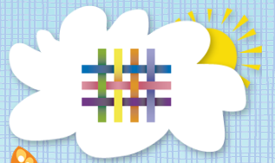

Workshops
We are hoping to run some workshops for parents to help you have a better understanding of how we teach the children and how they learn throughout the reception year. We would like to tailor these to things that you will find most useful. Please fill in the attached form to indicate where you would like more information or support on your child’s learning or development.

Reading
We teach the children how to read through phonics on a daily basis and they have lots of chance to practise their skills in school. However we do not have chance to read with every child every week. It is really important to practise these skills at home and we would encourage you to listen to and read with your child at least 3 times a week. Please write in your child’s reading log book and bring this to school every day. If you have misplaced it, please speak to your child’s class teacher.

Parent helpers
We really appreciate it when parents come in to help – it is a lovely opportunity for the children to work with others. We are always looking for helpers so if you are interested in coming in to help in reception please speak to your child’s class teacher.



Being independent
It would be wonderful if you could encourage your child to become more independent at home, for example getting dressed by themselves and using a knife and fork. Also when they come into school in the morning – please encourage your child to hang up their coat and sort out their reading back by themselves.

Bug Club
Don’t forget you have access to online ebooks through Bug Club at activelearn.co.uk





At the end of the year the children will be assessed on whether they have
‘met’ the early learning goals.
We will put up copies of these on our parents notice board but please ask if you would like a copy for home.

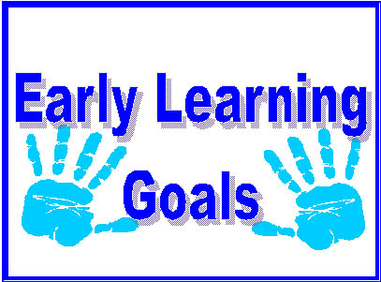

What can you do at home?
Please see the information and ideas overleaf to give you an idea of some simple things you can do with your child to help their learning develop at home.

Thank you, The Reception Team ☺

Pencil grips
We are working hard with the children to help build up the muscles in their fingers to help them become better writers. The way they hold their pencil is a vital part of this. These drawings show the progression children follow when learning to grip a pencil for drawing and writing.

At this point in the year we would hope that most children would be using the tripod grip, or almost there! If your child is not there are lots of things you can do to help!

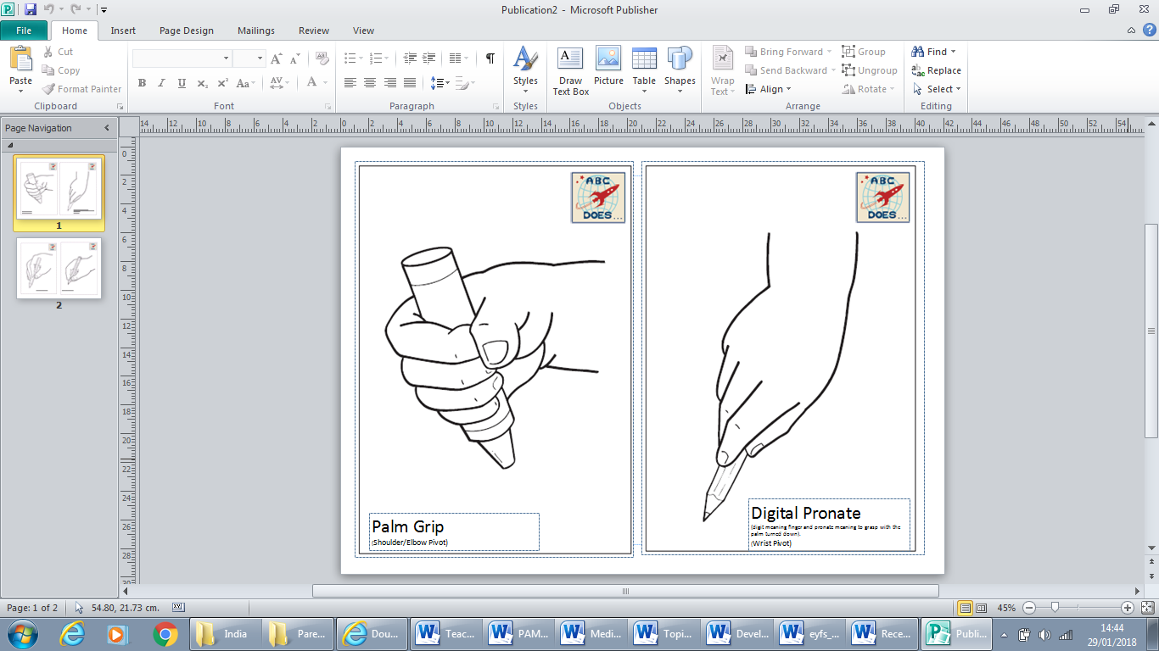
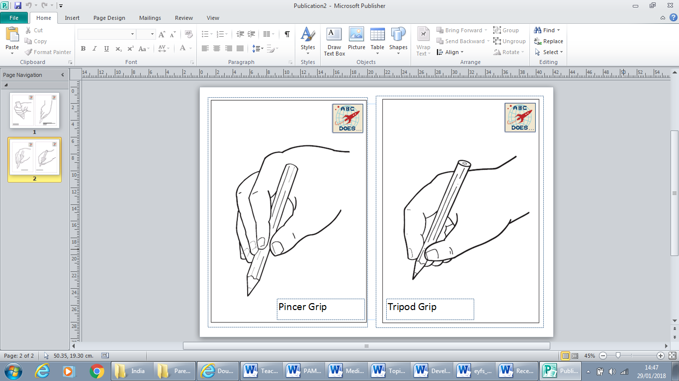
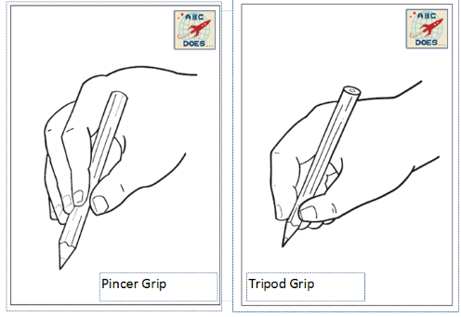


Scissors – practise using scissors to cut simple shapes
Threading – threading beads on to string or use a hole-punch in a piece if card

Playdough – squash, roll, squeeze and pinch
Tweezers – use them to pick up small objects like beads, seeds or buttons
Pegs – help hang out the washing, or practise attaching pegs to a basket

Writing
Get your child writing – in any way they want to! Maybe they want to write
a story, or help you write a shopping list, or even simply make a label for
their Lego model. These pictures are examples of children who are writing
at the ‘expected’ standard for the end of reception.

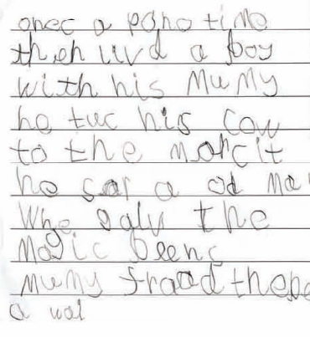

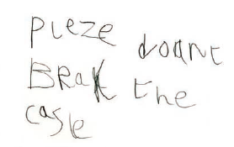
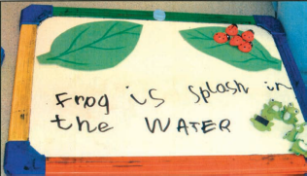
Maths
Numbers and shapes are everywhere!
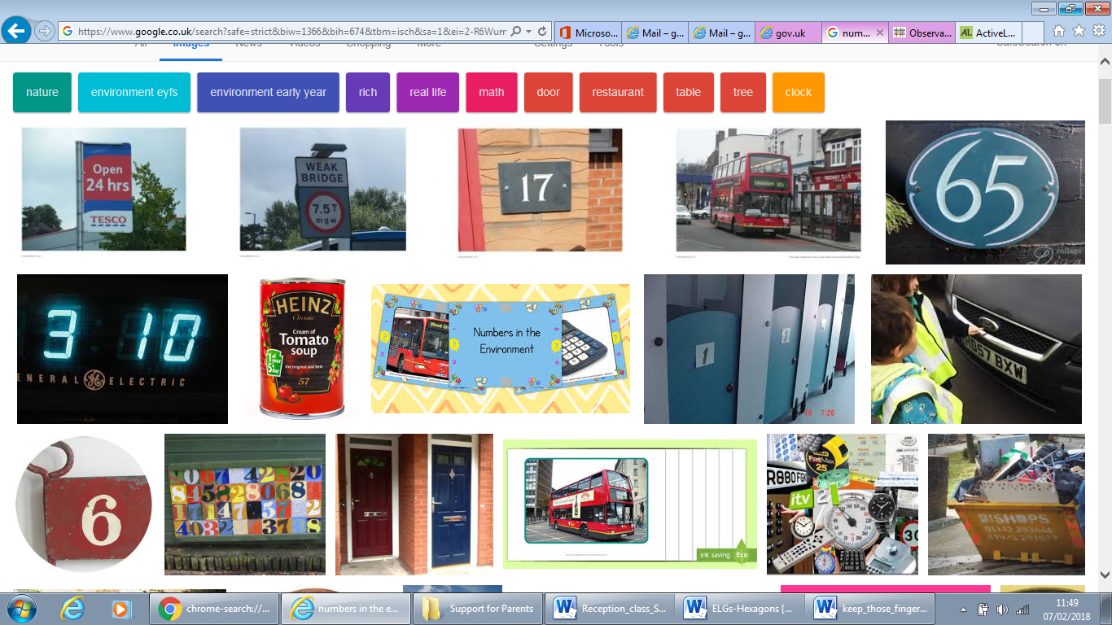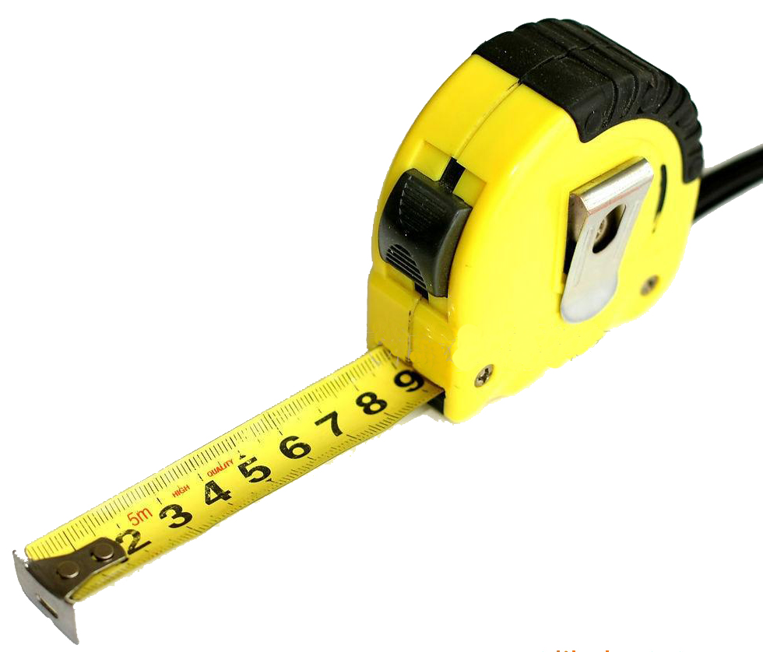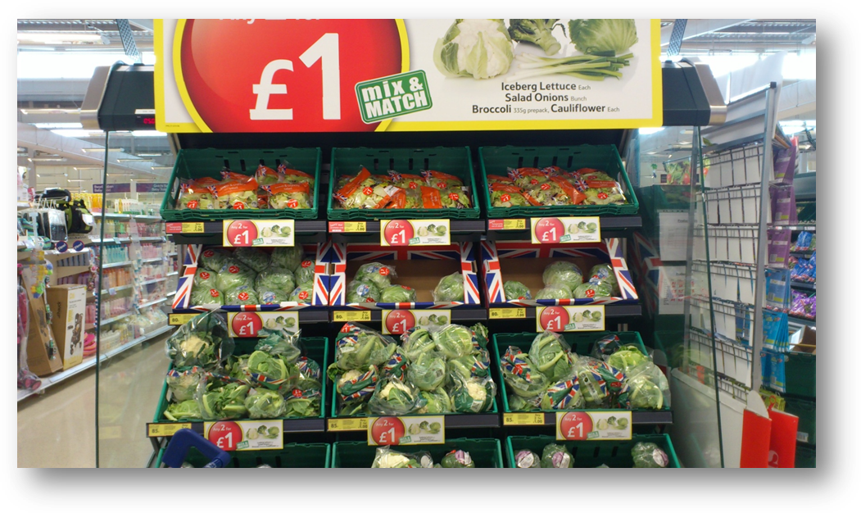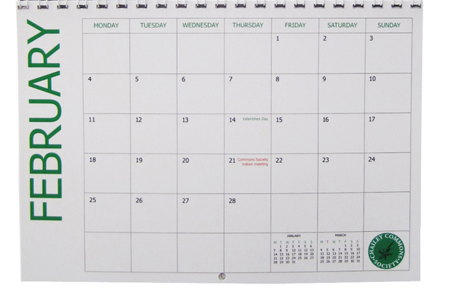

You can count anything – and it’s great for children to learn that all sorts of things can be counted. It’s very important that they learn to match their oral counting to a subject. For example if they have 5 apples to count, they say one number for each apple.
Watch this video https://m.youtube.com/watch?v=dvyLUpE6o7A if you want to know more.
You can also access games online using your activelearn password (same as Bug Club)
Information Overload!
We appreciate there is a lot of information here, but we want to give you as much knowledge as we can about the learning that takes place in the reception year. We hope it is useful and that you feel informed and confident in how you can help your child at home.
As always, if you want to talk anything through, please don’t hesitate to talk to your child’s class teacher.

