**PRIME AREAS**



In Personal and Social Education we will be:

* Looking at the wider world and stories that reflect similarities and differences.
* Continuing to learn about relationships with our friends and respecting their thoughts and feelings.
* Talking about things that will be different/ same in Year 1
* Taking part in transition visits to Year 1 and meeting our new teacher
* Discussing our feelings about Transition



In Physical development we will be:

* Joining in with aerobic activities including “Go-Noodle” as a class.
* Developing cooperation in team games and working together.
* Developing our skills for sports day such as running, jumping, aiming, skipping, throwing and dribbling
* Learning the importance of using equipment safely and keeping it under control.



In Communication and Language we will be developing our speaking and listening skills, attention and understanding through:

* Listening to and discussing a vast range of stories and texts.
* Learning stories by heart and acting them out.
* Talking about our learning using the animal characters.
* Discussing and sequencing our experiences in reception.

**Journeys by sea**

**Reception Summer Term 2 Overview**

Characteristics of Effective Learning focus: - This term we will be linking in with the whole school focus. Please see each class teacher if you would like an update on the focus for the week.

*Please ask if you are not sure what the animals represent or how we use them.*

Things to look out for:-

* Dressing up day.
* Sports Day.
* Sponsored skipping event.
* Our trip to the Model Village and Oddicombe Beach.
* The Garden Party.
* Transition day.

**Please could you bring a pair of trainers in for your child, so that we can go to the field and practice for sports day? Thank you.**

**SPECIFIC AREAS**

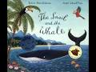

In Literacy we will be:

* Learning the story of “The Snail and The Whale” by heart.
* Consolidating our phonic knowledge and extending our ‘decodable/tricky word’ knowledge.
* Practising to write ‘decodable/tricky words’ by heart.
* Labelling pictures, making story maps, making books, writing labels, captions and simple sentences.
* Encouraging the children to write extended ‘Golden Sentences’ using joining words and adjectives (describing words).

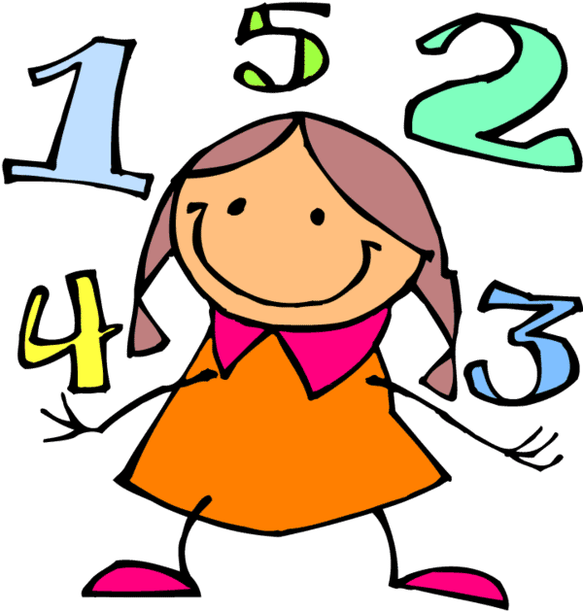

In Mathematics we will be:

* Looking at and using measurements such as length , capacity and weight and time.
* Recognising and ordering numbers- within 20 and beyond
* Problem solving using addition and subtraction with money
* Finding out more about numbers and number bonds
* Using the book “One is a Snail, Ten is a Crab”

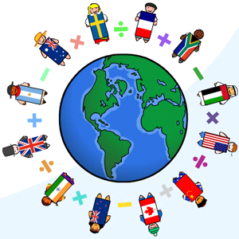

In Understanding the World we will be:

* Discussing our experiences of our trip
* Finding out about how we look after our world
* Discussing keeping safe in the water and the sun
* Looking at and learning facts about sea creatures.
* Using IT to help us learn about the sea and keeping safe and record what we find out

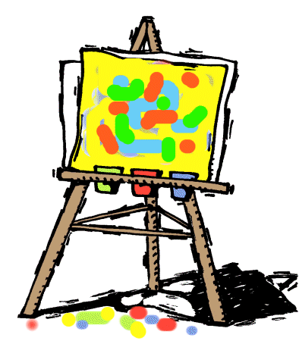

In Expressive Arts and Design we will be.

* Creating underwater scene/mobiles
* Exploring how to use different tools safely and effectively.
* Designing and making model boats
* Learning a song for our Garden Party performance.