Space Hook Day
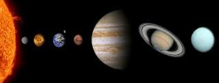
Dear parents and carers,
We will be starting off our Space topic with a hook day on Friday 8th January 2021. Your child can come dressed in anything related to space such as a starry dress, t-shirt with planets or something dark with a headband. Please do not buy anything especially for the day. We will be cooking rock cakes, building space rockets and making split-pin astronauts.
Please could you save your kitchen roll tubes and small boxes (oxo cube sized) for the rockets.
We hope that you have a wonderful, peaceful and safe Christmas holiday. Many thanks, Year 1 Teachers.

