Year 1 tricky words to practise reading.
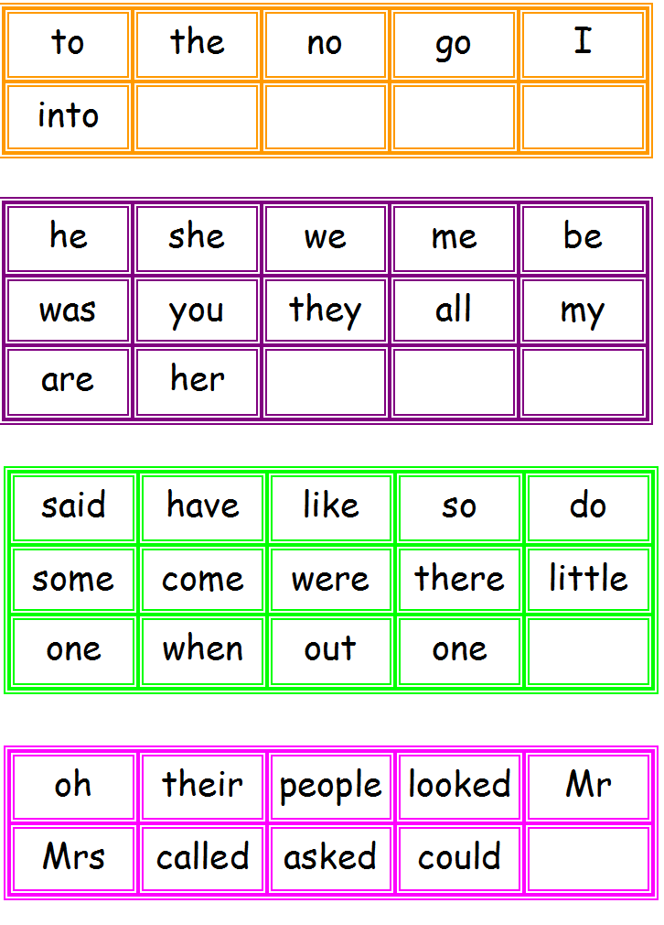
Year 1 Words to practise spelling
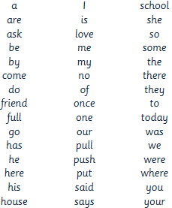
G:\COMMON FILES\COMMON FILES\Year 1\Year 1 tricky words.docx

