Year 2 Mathematics – What every child needs to know about maths by the end of Year 2
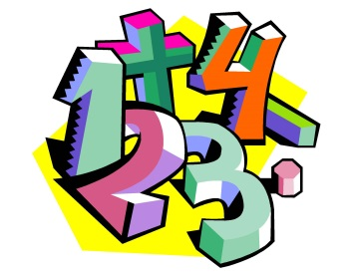

Purpose of study:
Mathematics is a very creative and interconnected subject that can provide the solution to some most intriguing problems. It is essential to everyday life, critical to science, technology and engineering, and necessary for financial literacy and most forms of employment. It therefore provides a foundation for understanding the world and the ability to reason mathematically. Here at Ladysmith Infant and Nursery School we hope to inspire in the children an appreciation of the beauty and excitement of mathematics, and help them to develop a sense of enjoyment and curiosity about the subject.

Curriculum Aims:
- become fluent in the fundamentals of mathematics so that pupils develop conceptual understanding and the ability to recall and apply knowledge rapidly and accurately to a variety of situations
- reason mathematically by following a line of enquiry, thinking about relationships and generalisations, and developing an argument, justification or proof using mathematical language
- can solve problems by applying their mathematics to a variety of routine and non-routine problems with increasing depth, including breaking down problems into a series of simpler steps and persevering in seeking solutions

Assessment:
Assessment of maths in Year 2 is mainly through teacher assessment. In February you will receive your child’s mid–year report which will indicate their progress so far and if they are ‘on track’ to reach the required standard in the maths curriculum by the end of the school year.
In May pupil’s undertake SATs (Standard Assessment Tests) and these are used to
inform the teacher’s final assessment in June.

Mathematics Statutory Requirements:

Number and Place Value

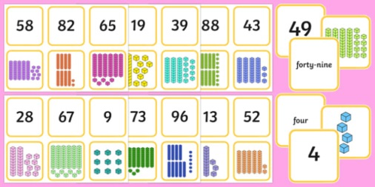
- Pupils should be taught to:
- count in steps of 2, 3, and 5 from 0, and in tens from any number, forward and backward
- recognise the place value of each digit in a two-digit number (tens, ones)
- identify, represent and estimate numbers using different representations
- compare and order numbers from 0 up to 100; use <, > and = signs

- read and write numbers to at least 100 in numerals and in words
- use place value and number facts to solve problems.

Number—addition and subtraction

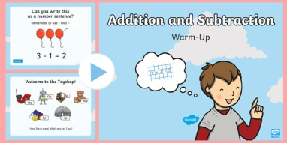
- solve problems with addition and subtraction:
- using concrete objects and pictorial representations, including those involving numbers, quantities and measures
- applying their increasing knowledge of mental and written methods
- recall and use addition and subtraction facts to 20 fluently, and derive and use related facts up to 100
- add and subtract numbers using concrete objects, pictorial representations, and mentally, including:
- a two-digit number and ones/tens
- two two-digit numbers
- adding three one-digit numbers
- show that addition of two numbers can be done in any order (commutative) and subtraction of one number from another cannot
- recognise and use the inverse relationship between addition and subtraction and use this to check calculations and solve missing number problems.

Number—multiplication and division
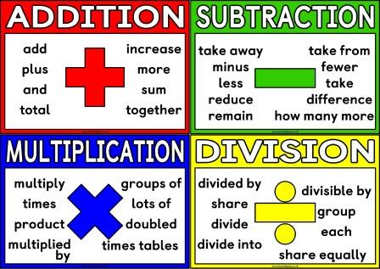
- recall and use multiplication and division facts for the 2, 5 and 10 multiplication tables, including recognising odd and even numbers
- calculate mathematical statements for multiplication and division within the multiplication tables and write them using the multiplication (×), division (÷) and equals (=) signs
- show that multiplication of two numbers can be done in any order (commutative) and division of one number by another cannot
- solve problems involving multiplication and division, using materials, arrays, repeated addition, mental methods, and multiplication and division facts, including problems in contexts.

Number—fractions
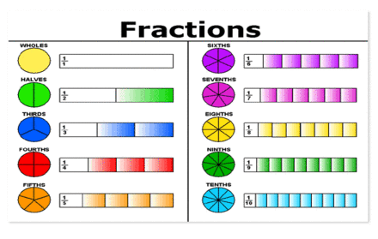
- recognise, find, name and write fractions 1/3, 1/4, 2/4 and 3/4 of a length, shape, set of objects or quantity
- write simple fractions for example, 1/2 of 6 = 3 and recognise the equivalence of 2/4 and 1/2

Measurement
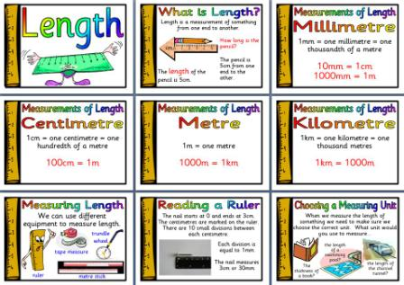
- choose and use appropriate standard units to estimate and measure length/height in any direction (m/cm); mass (kg/g); temperature (°C); capacity (litres/ml) to the nearest appropriate unit, using rulers, scales, thermometers and measuring vessels
- compare and order lengths, mass, volume/capacity and record the results using
- <, > and = signs
- recognise and use symbols for pounds (£) and pence (p); combine amounts to make a particular value
- find different combinations of coins that equal the same amounts of money
- solve simple problems in a practical context involving addition and subtraction of money of the same unit, including giving change
- compare and sequence intervals of time
- tell and write the time to five minutes, including quarter past/to the hour and draw the hands on a clock face to show these times
- know the number of minutes in an hour and the number of hours in a day.

Geometry—properties of shapes
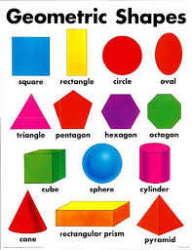
- identify and describe the properties of 2-D shapes, including the number of sides and line symmetry in a vertical line
- identify and describe the properties of 3-D shapes, including the number of edges, vertices and faces
- identify 2-D shapes on the surface of 3-D shapes, [for example, a circle on a cylinder and a tri-angle on a pyramid]
- compare and sort common 2-D and 3-D shapes and everyday objects.

Geometry—position and direction
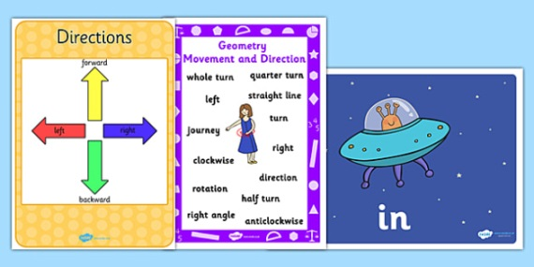
Pupils should be taught to:
- order and arrange combinations of mathematical objects in patterns and sequences
- use mathematical vocabulary to describe position, direction and movement, including movement in a straight line and distinguishing between rotation as a turn and in terms of right angles for quarter, half and three-quarter turns (clockwise and anti-clockwise).

Statistics
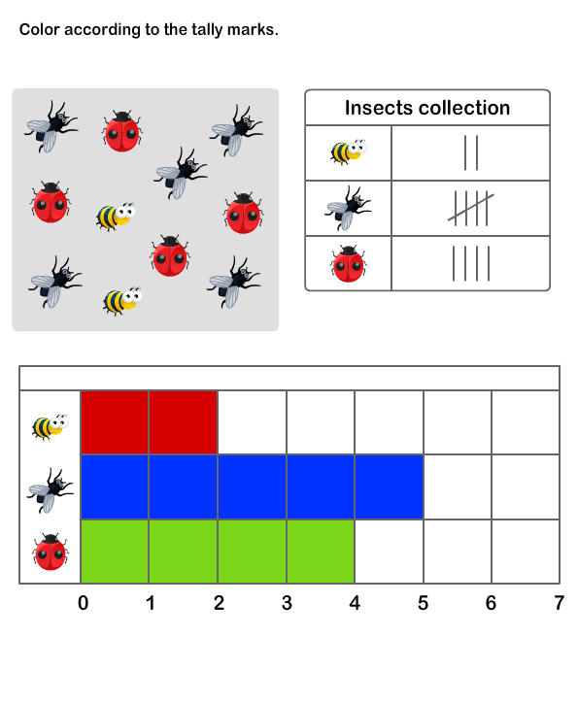

- interpret and construct simple pictograms, tally charts, block diagrams and simple tables
- ask and answer simple questions by counting the number of objects in each category and sorting the categories by quantity

Supporting your Child at Home

Online Resources:

1. www.bbc.co.uk/education/subjects/zjxhfg8 —no log in
needed. A range of number games and activities can be
found here.
2. https://nrich.maths.org/ - this will take you to their home
page. Then, select ‘Resources for ages 5-7’.
3. http://mathsticks.com/my/tag/ks1-5-7-yrs-2/ - here you will find a range of games and ac-tivities to play with your child.
4. We will be adding some maths games to the Active Learn page (the same one where your child accesses Bug Club.

Something to do…
- Count coins (real/plastic) in multiples of 2, 5 and 10
- Practise counting forwards/backwards in 2s, 3s, 5s and 10s
- e.g. 3,6,9,12,15,18,21,24,27,30 and 30,27,24,21...
- Please see the half-termly curriculum letter for further ideas

